myISS Request Form

## If you have a question for ISS

First check the [ISS website](https://www.mcgill.ca/internationalstudents/) and review the information provided in our guides and information sheets. This is where students should begin to find answers to their questions and is it also the quickest way to find information. Recordings of past webinars which are filled with valuable information can also be found on the ISS website.

## If the resources in the ISS website do not answer your question

Use the [ISS request form](https://int-mcgill-insight.symplicity.com/care_report/) to submit your question. This streamlined form for inquiries will allow ISS to better organize and respond to student questions.

* You will be asked to enter your name, McGill ID, the type of help you are looking for as well as details of your needs, and any supporting documents.

## 

* Once you submit your request for information, you will receive a confirmation of your submitted request in a web browser, and you will receive an email reply to your question(s) from ISS.

## If you have a follow up question

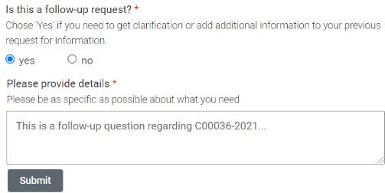

If you have a follow-up question, please submit a new Request for Information using the my[ISS request form](https://int-mcgill-insight.symplicity.com/care_report/) and indicate "yes" to the question “Is this a follow-up request?” and include the original request number under the “Please provide details” section.

myISS Student Portal

Use the myISS Student Portal to book an appointment with ISS and upload any additional supporting documents that need to be reviewed by an advisor prior to your appointment.

## Scheduling an appointment

**To schedule an appointment with an advisor, ISS needs to enable this option for you.**If after receiving your request for information it is determined that an appointment is needed, ISS will send you an email with instructions on how to book an appointment through the myISS Student Portal. Only students who have been granted access to Appointments in the myISS Student Portal will be able to book an appointment.

Most student questions can be quickly answered without the need for an appointment, so avoiding unnecessary appointments helps ISS respond to student questions more promptly.

***Booking policy****: Students can only book one appointment at a time.*

***No-show policy****: students who, for the second time, do not show up for the scheduled appointment or fail to cancel at least 24 hours before will not be able to book another appointment with an advisor for the rest of the term.*

### How to schedule an advising appointment

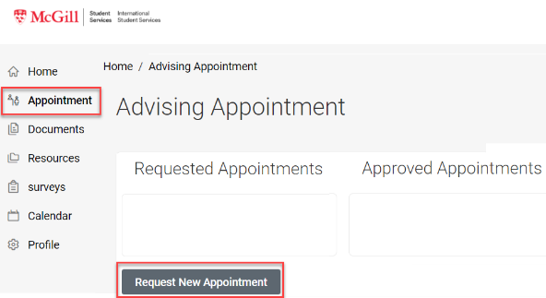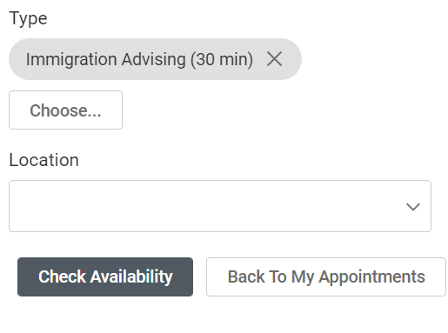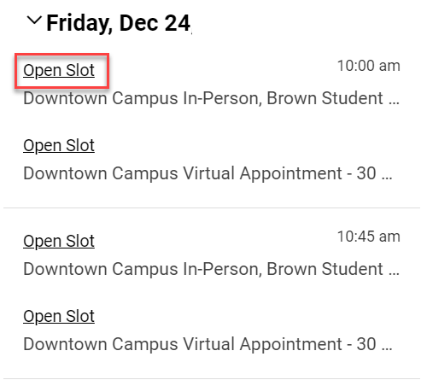

1. Login to the [myISS Student Portal](https://shibboleth-int-mcgill-insight.symplicity.com/sso/" \t "_blank)
2. Click **Appointment**
3. Click **Request New Appointment**
4. Select the Type of appointment
5. Optionally, you can select a Location. If you want to see all locations, leave Location blank.
6. Click **Check Availability**
7. Click **Open Slot** to select a time for the appointment.
8. Enter the reason for your appointment in “Additional Notes”.  
   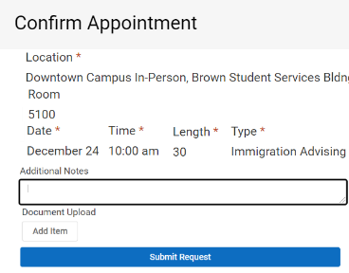
9. Click **Submit Request**
10. You will receive an email confirmation of your appointment and a reminder email within 24 hours of your scheduled appointment. The appointment will be listed under your “Approved Appointments”.
11. You can cancel or reschedule the appointment 24 hours prior to your appointment by clicking the three dots beside the appointment and selecting **Cancel** or **Reschedule**.  
    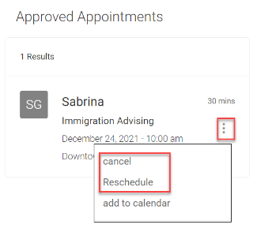
12. If you need to cancel your appointment less than 24 hour prior to your appointment, you must call or submit a request through the [myISS Request Form](https://mcgill.ca/myissrequest).

### How to submit documents

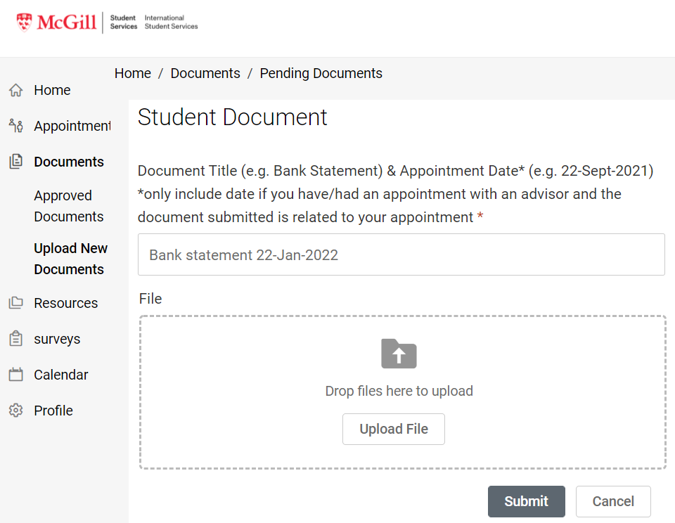

If you need to submit documents that need to be reviewed prior to the appointment.

1. Login to the [myISS Student Portal](https://shibboleth-int-mcgill-insight.symplicity.com/sso/" \t "_blank)
2. Click **Documents** > **Upload New Documents**
3. Click **Add New**
4. Enter a “Document Title” that includes the date of your appointment.
5. Upload the file
6. Add any comments needed about the document
7. **Submit**

The file will be added to your “Pending Documents”.

#### To see pending documents

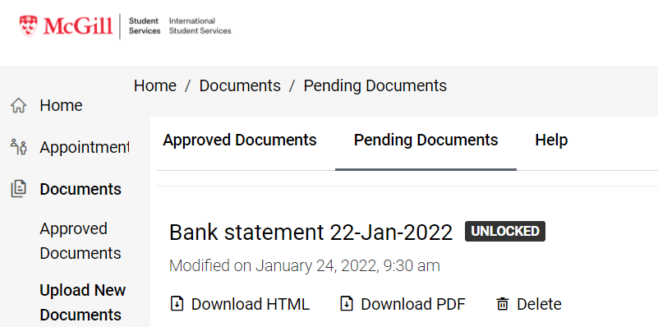

1. Login to the [myISS Student Portal](https://shibboleth-int-mcgill-insight.symplicity.com/sso/" \t "_blank)
2. Click **Documents** > **Upload New Documents**
3. Click **Pending Documents**

Your advisor will be notified about the new document, review it, approve it, and lock it (preventing you from deleting or replacing the document).

If the document is incorrect or more information is needed, the advisor will send you an email with instructions.

#### To see approved documents

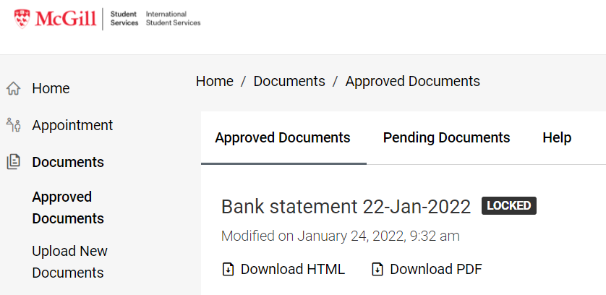

1. Login to the [myISS Student Portal](https://shibboleth-int-mcgill-insight.symplicity.com/sso/" \t "_blank)
2. Click **Documents** > **Approved Documents**
3. You will see that the document is locked; you cannot delete or replace it, but you can view it.

### How to find resources to help you prepare for your appointment

The Resource Library contains important documents to help you prepare for your appointments, and that provide information sheets on immigration.

1. Login to the [myISS Student Portal](https://shibboleth-int-mcgill-insight.symplicity.com/sso/" \t "_blank)
2. Click **Resources** > **Resource Library**