McGill LISTSERV Management Guide for List Owners

Contents

Logging on to McGill’s LISTSERV Server 2

Setting your default homepage and other Preferences 3

Get an overview of all the lists you manage 4

Manage list subscribers (members) 5

View all subscribers 5

Add a new subscriber 6

Remove a subscriber 7

Add/Remove multiple subscribers in bulk 9

Super-lists and sub-lists 10

View list archives 11

List Moderation 12

List Configuration 13

Using Newsletter and Announcement templates 16

Step 1: Set up your newsletter profile 16

Step 2: Create and send the newsletter 18

Customize templates for automated emails coming from the LISTSERV 24

Activity Reports 26

Additional resources 27

# Logging on to McGill’s LISTSERV Server

The recommended method of managing a LISTSERV list is to use the web interface at [https://lists.mcgill.ca.](https://lists.mcgill.ca./)

1. Click the **Log In** button at the top right of the page.

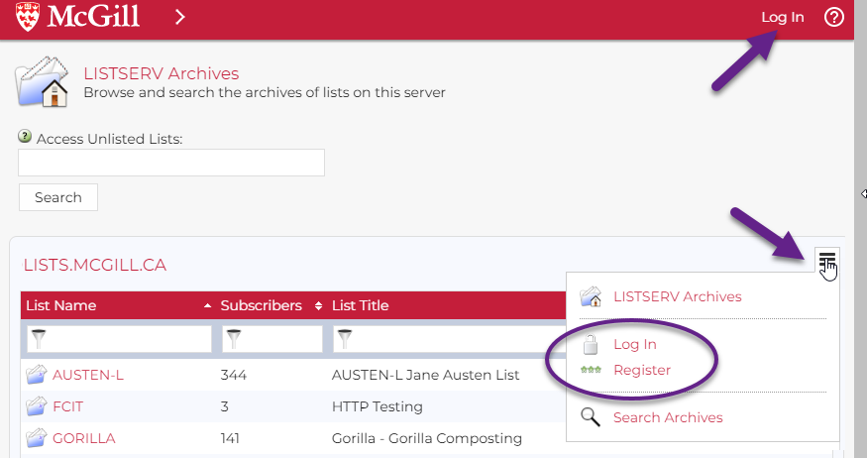

1. On the Login screen, enter your McGill username and your McGill password (the same password you normally use with your McGill systems)   
     
   Graphical user interface, application

   Description automatically generated

NOTE: Do not use the **Register Password** or **Forgot Password?** links from this page.

# Setting your default homepage and other Preferences

The default homepage that loads is the **LISTSERV Archives**, where you can see all the lists that are available to you. However, you can select your own preferred home page by clicking **Preferences** from the menu at the left side (under Subscriber Options), or via the menu icon  on the right, above the lists.

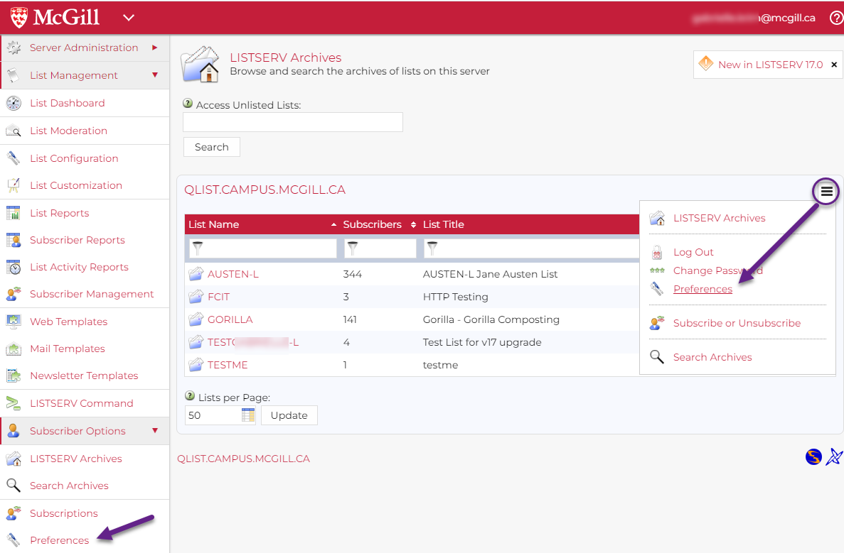

From the **Preferences** page, you may choose one of the following **Start Pages**: List Dashboard, List Moderation, Subscriber’s Corner or LISTSERV Archives.

* **List Dashboard** gives list owners a quick overview of all the lists and shows you if there are any messages awaiting moderation.
* **List Moderation** page is useful for those who have the **Moderator** role for one or more lists.
* **Subscriber’s Corner** shows which lists you are subscribed to
* **LISTSERV Archives** allows you to view messages that were posted to lists to which you are subscribed, as well as those you manage.

On the **Preferences** page, you can also choose your preferred **Mode** of usage (**Tutorial** **Mode** gives you the most onscreen hints).

# Get an overview of all the lists you manage

The table on this page will contain basic information about each list you have access to, including the list name, number of subscribers, owner(s), subscription options (how users are allowed to subscribe), sender options (who can send), etc.

To view more details about any list, click on its name. You can also navigate directly to view the subscribers or change other settings by clicking on the links within that table.

# Manage list subscribers (members)

## View all subscribers

1. From the **List Dashboard** page click on the number of subscribers to view the **Subscriber Reports** page. The page contains a table showing subscribers and their subscription date.

Graphical user interface, text

List subscribers page

1. Choose the Report Format:  
   Graphical user interface, application

   Description automatically generated  
   1. **Table** - For smaller lists (< 200), you may be able to view and manage all members from a table on screen; adjust the number of **Lines per page**.to view more at once.
   2. For larger lists you can choose to output the list in **CSV format**. This creates a comma-delimited text file that you download and open on your computer, using Excel or another application.

## Add a new subscriber

1. Go to the **Subscriber Reports** page.  
   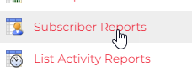
2. Under **Add Subscriber**, enter the person’s email address, followed by a space and their first and last name.
3. Check the **Send Email Notification** box if you want them to receive the standard email notification from the LISTSERV.
4. Click **Add Subscriber**.  
   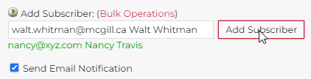
5. You should now see the person listed in the table of subscribers.

## Remove a subscriber

For relatively small mailing lists, you can remove members directly from the **Subscriber Reports** page. Check the box next to the name of the subscriber(s) you want to remove and click **Delete Subscribers**.

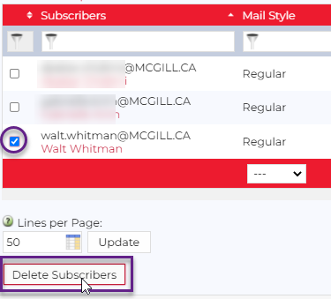

However, if you have a large mailing list it is easier to go to the **Subscription Management** page. Follow these steps:

1. Go to **List Management > Subscriber Management** from the left side menu.
2. Under **Search for Subscribers**, enter the person’s email address or their first and last name, and click **Search**.  
   Graphical user interface, text, application

   Description automatically generated
3. If the person is a member of the list, their setting information will be displayed on the following page:

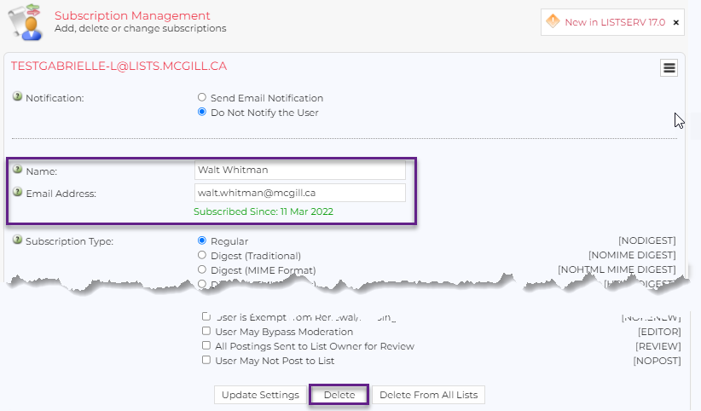

1. You can simply click **Delete** to remove them from the list. By default, no confirmation message is sent. Usually, you are deleting a member because their email address is no longer valid. However, you can select the option to **Send Email Notification** if needed.

## Add/Remove multiple subscribers in bulk

You can create a .csv or text file containing email addresses of subscribers you want to bulk import or delete.

1. Navigate to the **Subscriber Reports** page and click the link labeled **Bulk Operations**, above the Add Subscriber field.  
   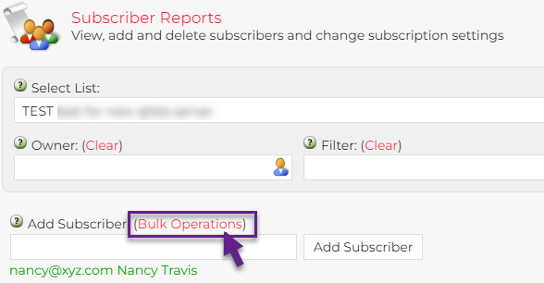  
   A pop-up window appears, where you can import your text file, containing the email addresses of the subscribers you want to add or remove, one email address per line.   
   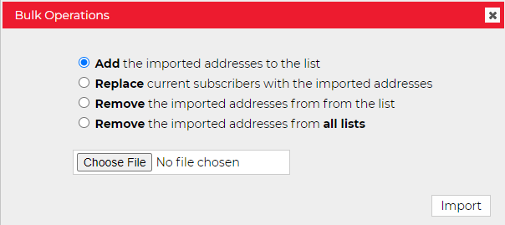
2. Select the operation you want to perform:
   * **Add** imported addresses
   * **Replace** current subscribers with the addresses you are importing
   * **Remove** imported addresses from the list
   * **Remove** imported addresses from **all lists**\*

|  |
| --- |
| **\* WARNING:** Make sure you select the right operation, or you may remove all members unintentionally. |

1. Upload your text file and then click **Import** to perform the operation (adding or removing members).

# Super-lists and sub-lists

A "super-list" is a "container" list that includes all the subscribers in a predefined set of sub-lists. This concept can be useful if you have multiple smaller groups that you post specific messages to individually, but you also want to be able to message all members in one shot. However, note that if there are different owners managing the sub-lists, it may be difficult to coordinate and ensure their membership is being managed appropriately.

If you are interested in setting up a super-list and sub-lists, submit a [LISTSERV request](https://mcgill.service-now.com/itportal?id=sc_cat_item&sys_id=e92e712b1b061c14313d8480cd4bcbec) and an IT Service Desk representative will assist you in setting this up.

# View list archives

1. From the left side menu, click LISTSERV Archives.
2. Click on the List Name to view the Archived posts for that list.

|  |
| --- |
| **NOTE**: List Archives configured as “Private” can only be viewed by their subscribers, editors, and owners. Only list archives configured as “Public” are available to non-members. |

1. Depending on the frequency of the archives, you may see links to weekly, monthly, yearly or individual messages.

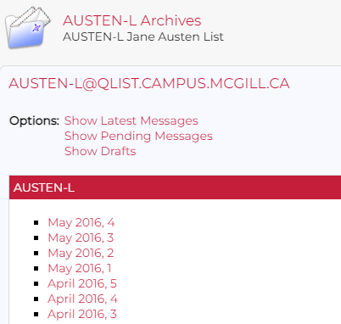

# List Moderation

By default, new lists are moderated by the list editor, who will need to approve all messages before they are distributed to the members.

1. Click **List Moderation** on the menu bar to open that page.
2. Select the list you want to moderate, if not already selected.
3. If there are messages awaiting moderation, they will be displayed on the page.
4. To approve/reject you can:
   * Select all messages at once and choose the desired **Action** (Approve, Reject, Reject and Serve Off). OR
   * View an individual message by clicking on its **Subject** and then take an action.

# List Configuration

When you requested your list, it was created by IT Services with a default configuration, based on your answers in the request form. If you have specific needs to configure your list differently, it is advised to discuss your needs with an IT Service Desk agent and have them assist with changes to the configuration settings.

**WARNING:** Any changes you make to the configuration of your list are your responsibility.

1. Click **List Management > List Configuration**
2. If the list you want to configure is not already selected, choose it from the dropdown list at the top of the page.
3. In the lower half of the page, you will see an overview of the main configuration settings, and you can click on each setting link to adjust, if needed.  
     
   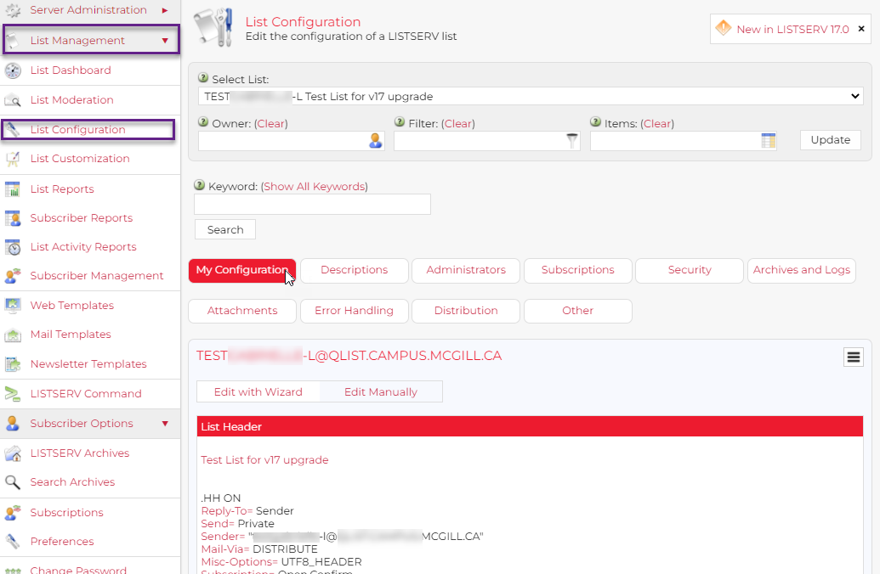

The buttons on the page allow you to adjust groups of parameters:

* **Descriptions-** Your list name and brief description, which will be sent to users when they subscribe.
* **Administrators** – Add/remove owners, editors, moderators and who can review subscriber information.
* **Subscriptions** – Who is allowed to subscribe to your list, who is allowed to post to the list, etc. It is recommended not to allow Public senders avoid unwanted postings (e.g. SPAM) to the list.

If the **Confirm** checkbox is selected, editors will have to confirm any postings prior to their distribution. This box is unchecked (no confirmation needed) by default.

* **Security** – Who can view your list from the LISTSERV website; **Confidential** means it will not be included in the global directory of LISTSERV lists at <http://www.lsoft.com/lists/listref.html>.
* **Archives and Logs** – Who is allowed to view archived posts, how often archives are created, the name of the archives folder, etc.  
  NOTE: Because of space requirements there is no guarantee that all postings will be kept indefinitely nor that all requests for archiving lists will be approved. By default archives will be created **monthly**.
* **Attachments** – Determine what types of attachments are allowed in your list and limits on the size. By default, messages posted to the list can contain attachments as part of the messages. The type of attachment can be restricted. The example screenshot below indicates that images of the specified types are allowed. Checking the Filter box, means messages containing non-approved attachments will be posted, but the offending attachments will be stripped out. Click the (?) icons on screen to learn more.
* **Error Handling** – where errors are logged
* **Distribution** – How mail is delivered.
* **Other** – Miscellaneous settings for mail message delivery and language interpretation

1. On each configuration page, click the question mark icon next to a setting to view help on what it means and how it applies.

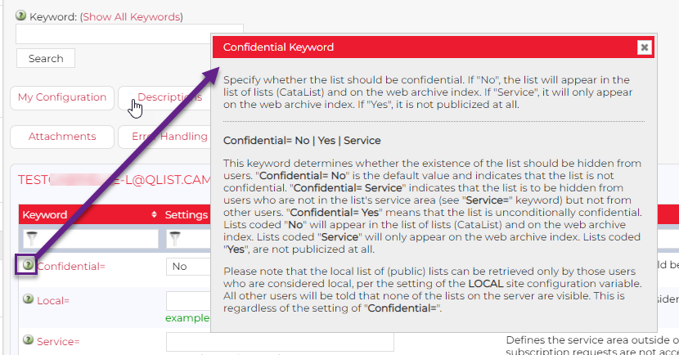

For additional information on configuration list settings, see the complete [LISTSERV List Owner’s Manual.](http://www.lsoft.com/manuals/16.0/LISTSERV16.0_ListOwnersManual.pdf)

# Using Newsletter and Announcement templates

Predefined templates make it easy to send professional-looking newsletters and announcement emails to your list. There is even a McGill-branded template that you can customize for either multi-section newsletters or simple announcements.

* **Newsletter** templates contain multiple sections within the body of the email, so that your email can display many different articles or topics.  
  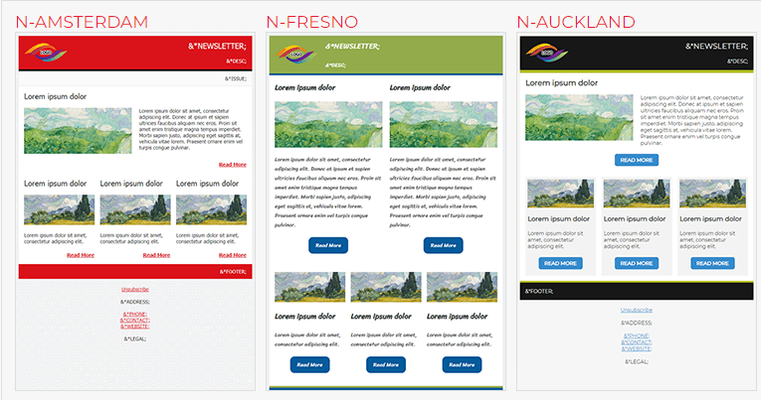
* **Announcement** templates generally have one main body area with a space for an image.   
  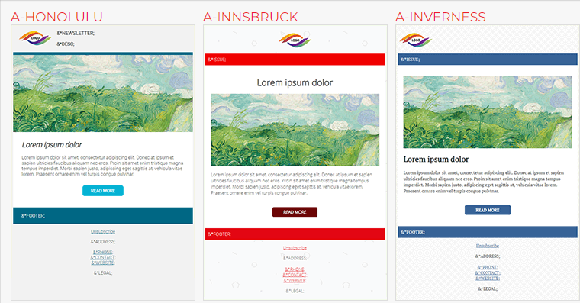
* **Both** Newsletters and Announcementscontain header and footer areas.

There are many template styles from which to choose, and you can customize them to create your own. We have defined a McGill-branded template that includes the McGill logo and red background in the header and footer. It has multiple sections, but you can choose which sections and how many you want to use (e.g., 1 single-column image with image and text, 3 double-column sections and 0 three-column sections)

## Step 1: Set up your newsletter profile

1. Select **Preferences** from the menu icon on the right side of most pages, or from the left side navigation pane.  
   Graphical user interface, application, PowerPoint

   Description automatically generated
2. On the **Preferences** page, click **Newsletters**

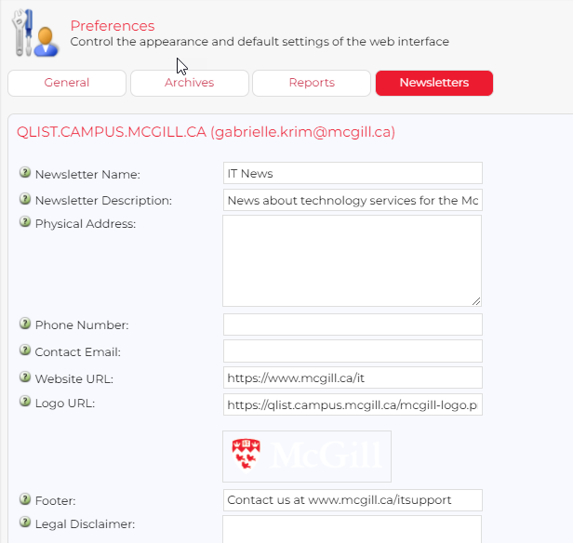

Here you can define a specific information that will be used by default in all your newsletters, no matter which template you choose.

* **Newsletter name** – the name that will appear in the header at the top of the newsletter
* **Newsletter description** – appears in the header just below the name
* **Physical address, phone number, and contact email -** appear below the footer in most newsletter templates.
* **Website URL –** if you have a specific website you want to attach to all messages
* **Logo URL –** your logo (keep in mind that the McGill-branded template already includes the McGill logo)
* **Legal Disclaimer** – Text to appear after the footer

|  |
| --- |
| **NOTE:** This Newsletter Profile will be used for all the LISTSERVs you manage. However, you may change the content while drafting your newsletter. |

## Step 2: Create and send the newsletter

1. From the left side navigation menu, select **List Management** > **List Dashboard**. This will display all the lists you currently have access to.
2. Click on the name of the list to which you’re sending the newsletter.
3. Click on the menu icon on the right side of the page and choose **Send Newsletter**.  
   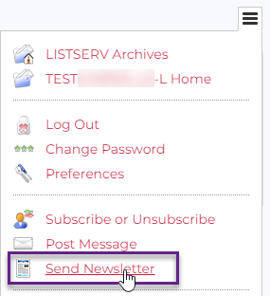
4. On the **Templates** tab of the **Newsletter Creation** page, choose one of the many pre-formatted newsletter or announcement templates.   
   You can scroll through the thumbnail images on the page …  
   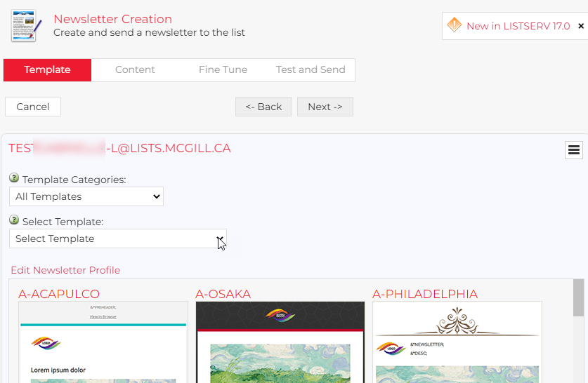  
     
   … or click the arrow next to **Select Template** to choose one by name. Note that here you can see the **McGill**-branded template.  
   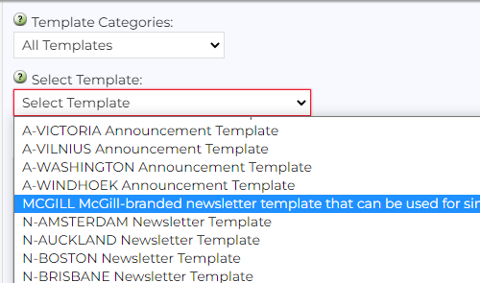
5. As you select a template, it will appear on the page. Once you are satisfied with the selected template, click **Next** at the top of the page to move to the **Content** tab.  
   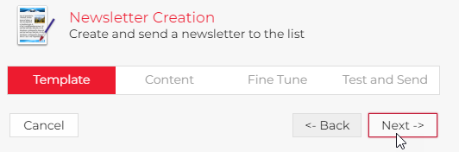
6. In the top portion of the Content tab, enter the **Name** and **Subject** for your newsletter or announcement.
7. For each of the **Block** types defined in the template, you can specify how many to include in your newsletter body (e.g., 1 full-width, 0 half-width and 3 third-width blocks) and the newsletter design will adapt so that you can add content in each area.   
   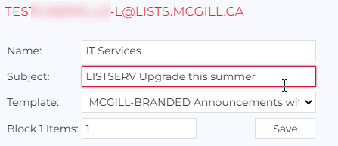
8. Click **Save** to preview the newsletter layout. Each of the template placeholders starts with **&\*** and ends with a semicolon**;** you can replace them with your own text and/or images.
9. Simply click on the placeholder within the preview and a pop-up box will open, where you can enter your own text …  
   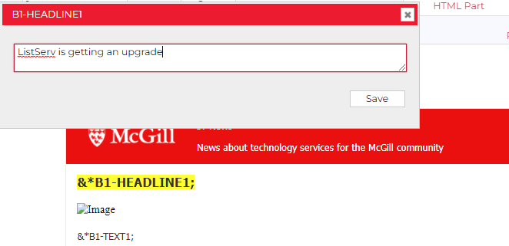

… or the URL of an image from a website (e.g., https://www.mcgill.ca/site/files/mypicture.jpg)  
  
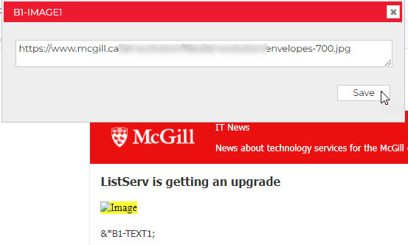

1. Click **Save** to see your changes appear on the page.   
   Note that any placeholders you have not edited will remain on this page but will be removed from the final version.
2. Click **Preview in New Window** to get a better sense of the end result, with all placeholders removed.  
   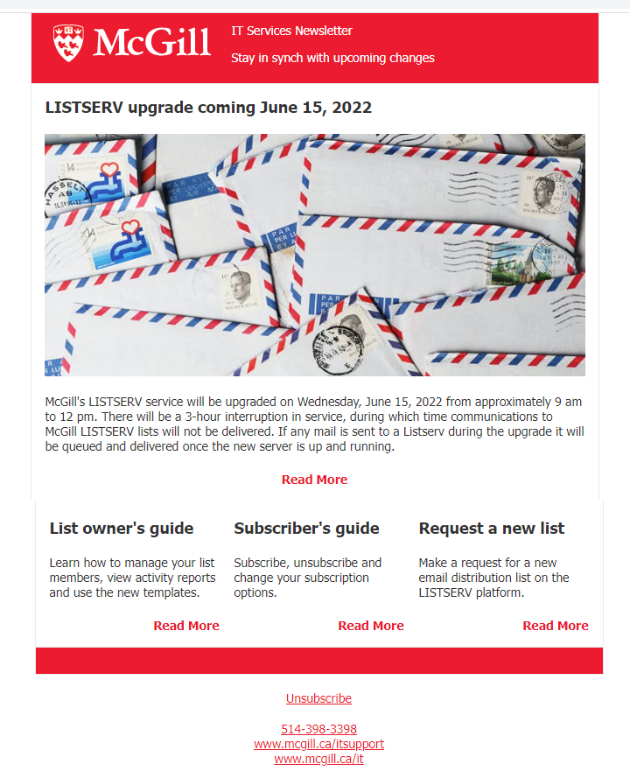
3. Click **Next** at the top to **Fine Tune.** This is where you can make additional adjustments to formatting, using either plain text or an HTML editor.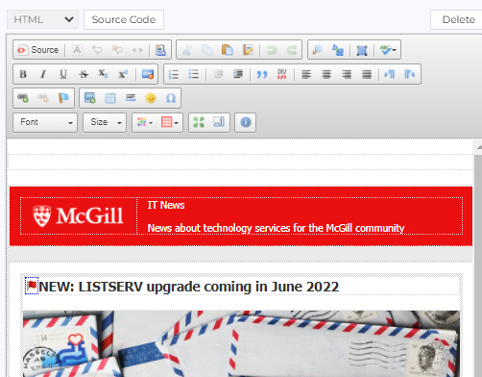
4. Click **Next** at the top to **Test and Send**. You may send a test email to one or more specific email addresses to ensure your newsletter will appear the way you want in the recipients’ email inbox.  
   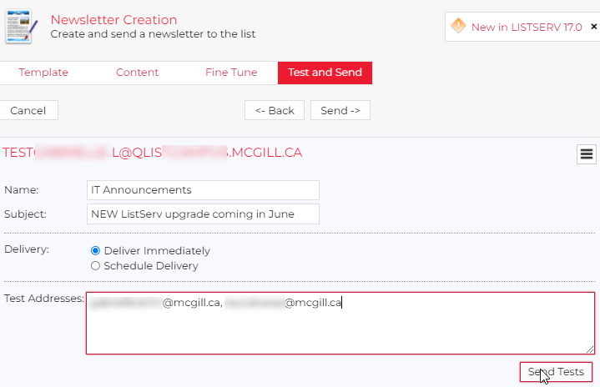

If you need to go back and revise content or formatting, click **Back** at any time.

1. Once your newsletter is ready, you have a choice of delivery options:
   * **Deliver immediately** – The message/newsletter will be distributed to your list members as soon as you click **Send.**
   * **Schedule Delivery** – You can choose a date and time in the future; once you click **Send**, your message/newsletter will be distributed according to your scheduled settings.

# Customize templates for automated emails coming from the LISTSERV

|  |
| --- |
| **CAUTION:** These mail templates contain placeholders for the list name and default email addresses that are based on the values in your list configuration. Modifying these templates is not advised. |

1. From the left side navigation pane, click **List Management > Mail Templates**  
   This page contains default messages sent by the LISTSERV to subscribers based on events, such as being added or removed from a list.

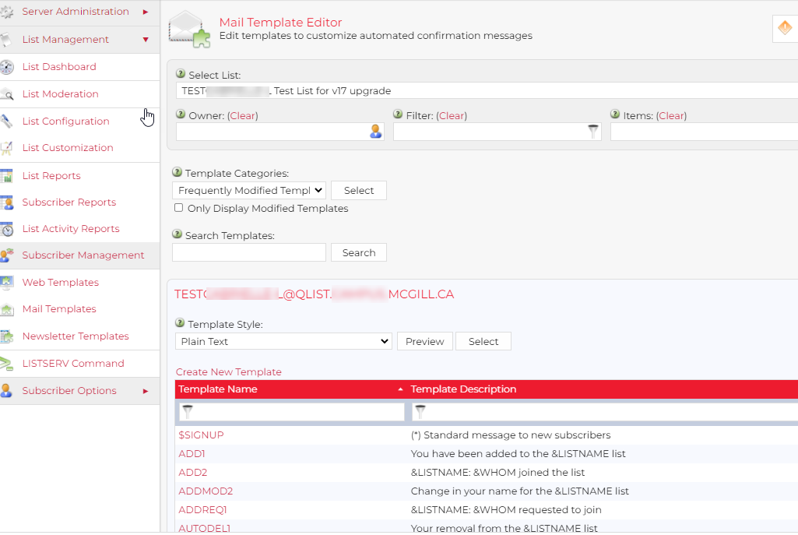

1. Click on the link for a particular mail template to edit it if needed.   
     
     
   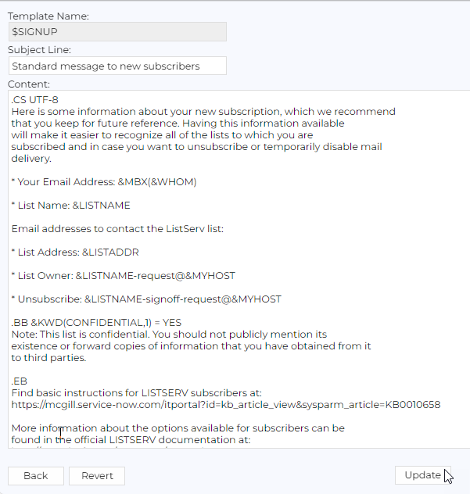
2. Add your own text message and click **Update** at the bottom. You can always click **Revert** to go back to the default.

# Activity Reports

The List Activity Reports can show when subscribers have joined or left the list, dates and times of specific posts to the list, and more.

1. From the left side navigation bar, click **List Management > List Activity Reports**   
   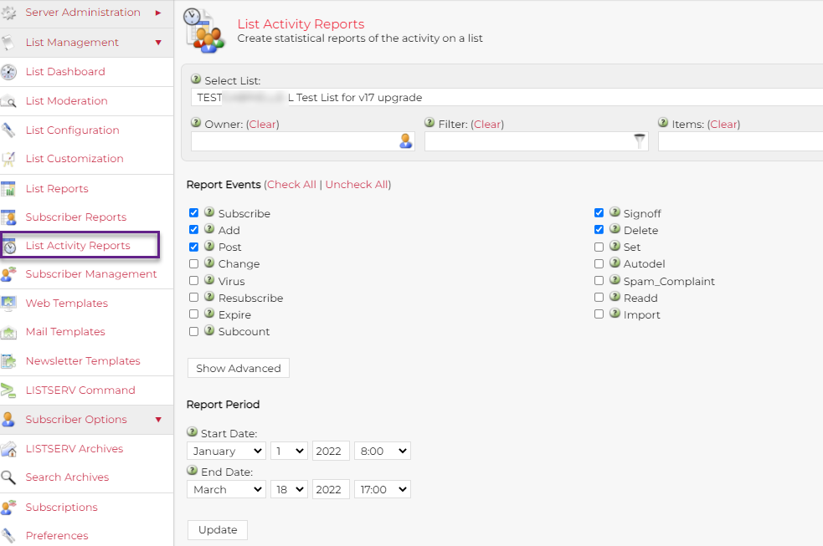

1. At the top of the page, select the list for the report, if not already selected.
2. Choose the events you would like to include, such as Subscribe, Add, Delete, Post, etc.
3. Under **Report Period**, choose the start and end dates
4. Choose the type of data to include:
   * **History** – gives you the date and time and details of each event
   * **Statistics** - gives you counts of each type of event during the specified period
5. Under **Report Format**, choose how you want to view the report:
   * **Table** - displays the events onscreen (OK for smaller reports)
   * **CSV format** - will download a file that you can open in Excel.  
     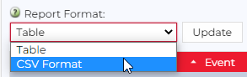
6. Click **Update** to generate the report.

# Additional resources

* [LISTSERV owner’s Manual v.16 from L-Soft](http://www.lsoft.com/manuals/16.0/LISTSERV16.0_ListOwnersManual.pdf)
* [How to use a LISTSERV (for list subscribers)](https://mcgill.service-now.com/itportal?id=kb_article_view&sysparm_article=KB0010658)
* [Request a new LISTSERV list](https://mcgill.service-now.com/itportal?id=sc_cat_item&sys_id=e92e712b1b061c14313d8480cd4bcbec)
* For additional help contact the IT Service Desk at [www.mcgill.ca/itsupport/servicedesk](http://www.mcgill.ca/itsupport/servicedesk)