LimeSurvey 3   
User Guide to

Creating Surveys

Created: October, 2020

Last updated: November 9, 2020

Contents

What has changed from LimeSurvey v2 to v3 5

Getting started 5

Requesting a LimeSurvey account 5

Logging in and accessing your survey 5

Overview of the LimeSurvey interface 6

Left side navigation menus 7

Top menu navigation 8

Overview 9

Step 1) Create a survey 10

Your first survey 10

Import an existing survey from LimeSurvey version 2 10

Export survey from previous version 10

Import an existing survey from .lss file 11

Step 2) Adjust your survey settings 13

General settings 13

Text elements (welcome, end messages) 15

*NEW: Data policy settings 16

Presentation & navigation settings 17

Publication & access control 19

Theme settings 20

Notification & data management settings 21

Participant settings (Tokens) 23

Step 3) Add and edit questions 24

Creating a question group 24

Editing or deleting a question group 25

Adding questions 25

Question options 30

General options 30

Display 30

Input 31

Logic 31

Statistics 32

Adding answer options and sub-questions 32

Reorder groups or questions within a group 34

Setting conditions 35

Setting a simple condition for a question 35

Setting conditions on a question group 38

Quotas 40

Step 4) Preview the survey or questions 41

Preview survey 41

Preview question group 41

Preview question 41

Step 5) Manage participants 42

Initialize the participant table 42

Import a list of participants 42

Generate tokens for participants 44

Step 6) Activate your survey 45

Activate the survey 45

Step 7) Invite participants 46

Open, anonymous surveys 46

Invitations for managed participants 46

Edit invitation email templates 46

Send email invitations to your participant list 47

Step 7) Analyse survey results 49

Browse survey results 49

View survey results 50

View Statistics 52

General filters 52

Response filters 54

View and interact with statistics 54

Interact with charts dynamically 54

Simple mode 55

Close a survey 56

Expiration 56

Deactivation (stopping the survey manually) 56

Exporting results 58

Export results to Excel 58

Exporting survey data in SPSS 60

# What has changed from LimeSurvey v2 to v3

* Log into the system with your McGill username and password, same as logging into most other McGill systems. No need to keep track of a separate password.
* New feature to add a consent form, to which participants must agree before continuing with the survey. This is useful for research surveys that require a standard confidentiality / privacy consent form. See *NEW: Data policy settings
* For those with web publishing expertise, you can now customize the look & feel of your survey by adding a Cascading Style Sheet (CSS) file.
* Interface organization has changed, but all the same elements are present.

# Getting started

### Requesting a LimeSurvey account

If you have never used McGill’s LimeSurvey tool, you will need to request access. Submit a general request form on the IT Support site at [www.mcgill.ca/itsupport](http://www.mcgill.ca/itsupport) to request access to LimeSurvey and to have a blank default survey created.

### Logging in and accessing your survey

* Once you have been granted access, you will receive an email with instructions on how to log in. Go to <https://surveys.mcgill.ca/ls3/index.php/admin> and enter your McGill username (first.last@mcgill.ca, first.last@mail.mcgill.ca or first.last@affiliate.mcgillca) and the password you normally use with that username.
* If this is your first survey, a default survey should have been created for you. Click **List available surveys** from the survey home page and click on the name of your survey from the “**Surveys**” list.

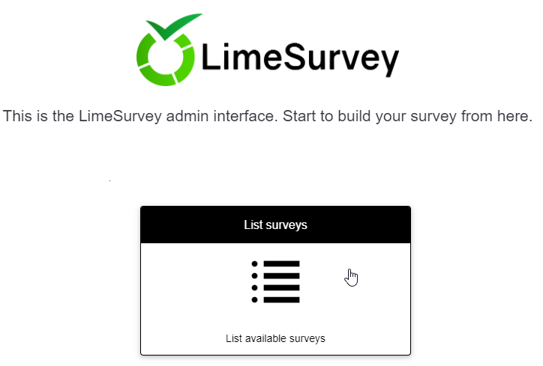

# Overview of the LimeSurvey interface

After signing into the LimeSurvey site, click **List available surveys** to access the surveys for which you are the administrator.

For each survey, you will see the Survey ID, Status (active, inactive, expired), Title, date Created, Owner and information about the responses received.

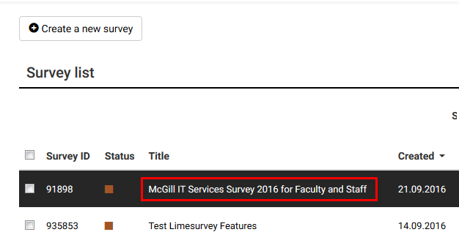

Click the title of the survey you want to work on. When the survey opens, you will notice a navigation menu on the left side, and a content pane filling most of the screen.   
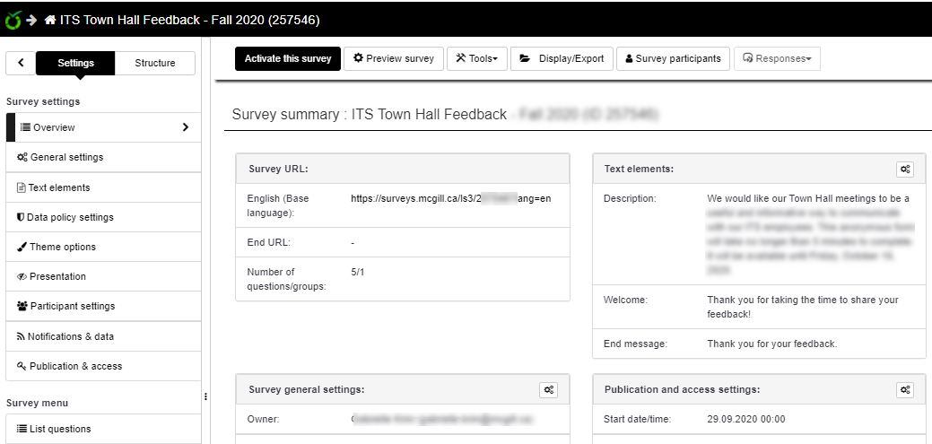

## Left side navigation menus

The navigation pane is divided into two main tabs:

**The Settings tab** is further divided into two menu groups:

* **Survey settings:** options here allow you to view and edit elements related to survey activation, text of the welcome and conclusion messages, theme (colors and text styles), how participants will navigate through your questions, etc.
* **Survey menu:** These options allow you to view and organize questions, as well as manage survey participants (for surveys that are closed to a specific participant list).  
    
  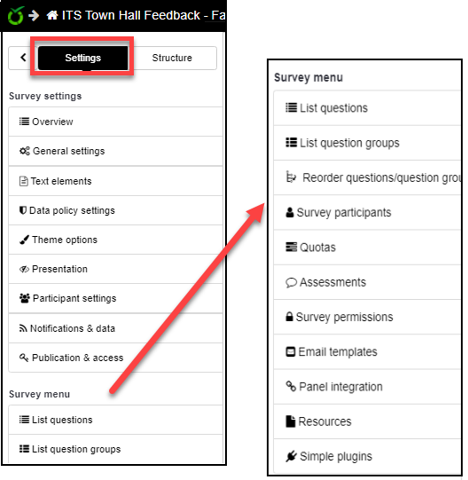

**The Structure tab** gives you a shorter menu of options related to the actual survey questions.   
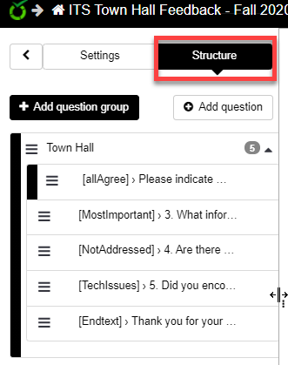

## Top menu navigation

The menu options at the top of the content pane change depending on the page you are looking at. The relevant top menus are described in more detail within each topic.

|  |  |
| --- | --- |
|  | **TIP:** Whenever you are done making changes to a component or question, if you simply click **Save**, you will remain on that page. Click **Save and close** to return to the previous page. |

## Overview

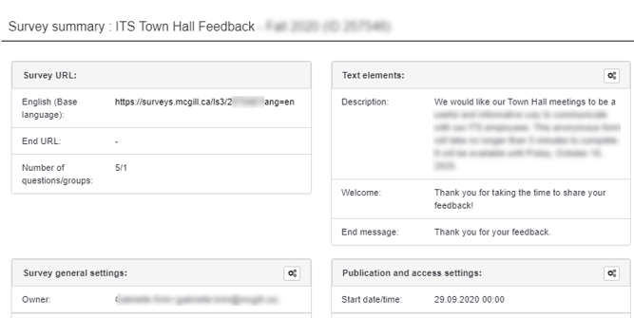

The survey **Overview** page appears when you first open your survey. It contains several settings widgets for quick access:

* **Survey URL:** This is the web address participants will use to access and complete your survey. If your survey is multi-lingual, you will have different URLs for each language, and participants are given an option to switch between languages.
* **End URL:** You can specify a web page that will open once the participant submits the survey.
* **Survey general settings:** Information about the owner and administrator
* **Text elements:** These are the introductory and closing messages that appear apart from the survey questions.
* **Publication and access settings:** Conditions for when the survey is available, and how it is presented.

You can open these widgets to edit them by clicking the icon in the top right corner of the widget;   
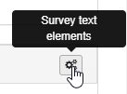

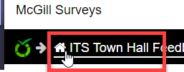They are also available from the **Survey settings** menu in the left side navigation page.

To get back to the **Overview** page at any time, click on the home link and survey title above the navigation pane.

# Step 1) Create a survey

## Your first survey

If you are new to using LimeSurvey, your first survey will be created for you. You can just open it and begin adjusting the general settings, such as adding a welcome message, choosing a template and deciding how you want users to navigate.

## Import an existing survey from LimeSurvey version 2

If you have an old survey in the previous version of LimeSurvey (v2), and you want to use it as a basis for a new survey, follow the steps below to Export from the previous version, and import into the new LimeSurvey (v3) tool.

### Export survey from previous version

1. Navigate to the survey you want to export. From the home page click the **Display/Export** button in the top menu and select **Survey structure (.lss)**

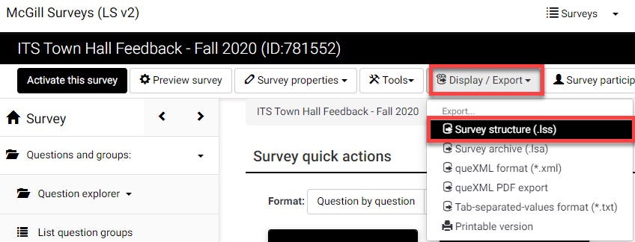

1. The .lss file will be downloaded to your computer so that you can import that structure into the new version of LimeSurvey.

|  |  |
| --- | --- |
|  | **IMPORTANT:** If you have submission data from this survey that you have not exported, it will be inaccessible once the old version of LimeSurvey is decommissioned. We strongly advise you export the submission data into a file format, such as Excel for future reference. |

### Import an existing survey from .lss file

1. After you log into LimeSurvey, from the top menu of the Surveys homepage, click **Surveys > Import a survey**.

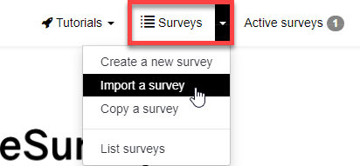

1. On the **Import** tab, click **Choose File** and select the .lss file you exported from the previous survey.   
   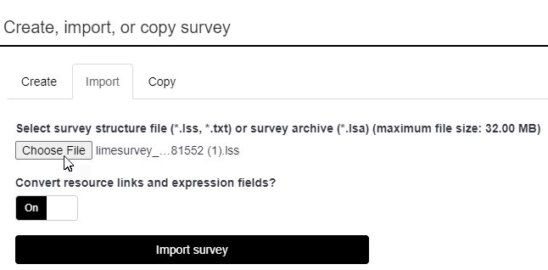
2. 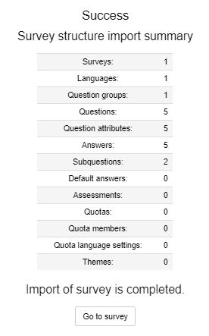Click **Import survey**. If successful, you will see a “**Success**” page, with additional details about what was imported. You may also see additional **Warnings** if there were conditions the update feature was not able to handle.
3. Click **Go to survey** to access the new survey.
4. Click **Preview survey**, in the top menu of the survey page and run through each question to ensure it behaves as expected.

After importing an older survey, you may want to choose a new template, or adjust the display and navigation settings. See instructions for **Survey Settings** below.

# Step 2) Adjust your survey settings

## General settings

You can edit the appearance (theme) and general survey settings by clicking **General settings** from the left side navigation pane.

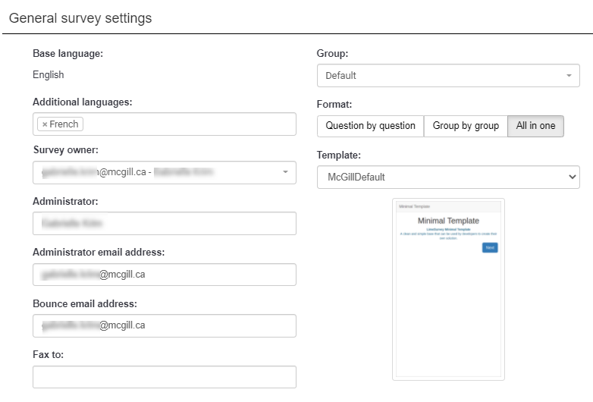

**Languages:** The Base language is English, but you can choose additional languages; for each language you select, you will be able to add translations for all text elements (e.g., welcome messages, as well as questions).   
LimeSurvey will generate separate URLs for each language so that you can send your participants links to the language of their choice. Participants will also have the option to switch between languages.   
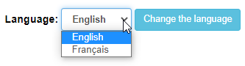

**Survey owner:** This is the person responsible for running the survey and collecting the results.

**Administrator**: One or more survey administrators can be listed; these people are responsible for technical aspects of the survey. The Administrator name(s) will be included in emails sent out inviting participants to respond.

**Administrator email address:** If participants need support, or in case of errors, notifications are sent to the address(es) listed here. Separate each email address with a semi-colon (;)

**Bounce email address**: This is the email address where a delivery error notification email will be sent. By default, this is the same as the administrator's email address.

**Fax to**: This field is used to give a fax number on the "printable survey" - ie: if you want to send someone a hard copy because they cannot use the online survey.

**Format**: Select how you want the questions to appear:

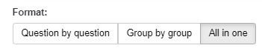

* **Question by question** – each question appears on a separate page. Good for surveys with detailed questions that require a lot of reading, and questions with many sub-questions and/or multiple-choice options.
* **Group by group** – when you create question groups, each group of questions will appear on the same page.
* **All in one** – all questions appear on the same page; a good choice for relatively short surveys (less than 10 short-answer questions). **NOTE**: Do not choose this option if you plan to display a data privacy/consent policy that the participant must accept.

**Template**: There are a few different styles for colors and fonts. The McGill default template is branded with a McGill logo and features simple gray colors.

Select a style and preview your survey to see how each type of question is displayed.

You can make further adjustments to the appearance and navigation in the **Presentation & Navigation** section.

## Text elements (welcome, end messages)

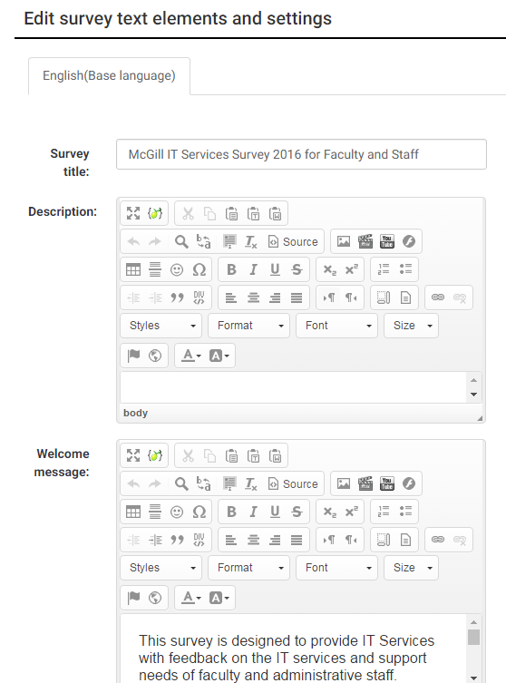From the navigation pane, click **Settings > Text Elements** to enter / edit the following:

* **Survey title** – appears at the top
* **Description** – for internal purposes
* **Welcome message** – the text participants see when they enter the survey, “Your voice matters… ”
* **End message** – the message participants see when they submit their responses, e.g., “Thank you for helping improve… ”

|  |
| --- |
| Note that most of the fields contain a WYSIWYG formatting menu with controls to allow flexible text styling and images. |

* **End URL** - This URL will be presented as a link at the end of the survey and allows you to direct your participants back to your home page (or any web page).   
  The End URL starts with "http://", e.g., [http://www.mcgill.ca](http://www.mcgill.ca.)
* **URL description**: The description for the link using the End URL.
* **Date format**: Choose how you want dates to be displayed.
* **Decimal mark**: By default, the decimal for numbers is a point, but you can choose comma (,) if you prefer.

## *NEW: Data policy settings

This new feature allows you to display a confidentiality statement/ consent form that the participant must agree to before continuing to fill out the survey.

|  |  |
| --- | --- |
|  | **IMPORTANT:** If you are requiring the participant to agree to the data policy before continuing the survey, you must choose to display your questions using the format **Group by group** or **Question by question** in the **General settings** page. |

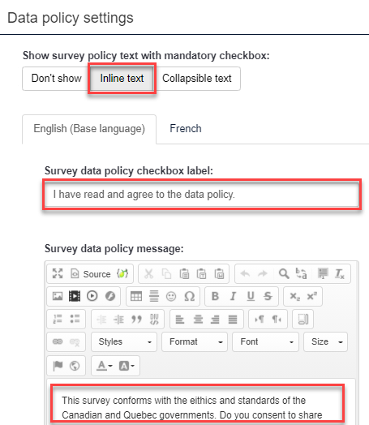  
From the **Settings** tab of the navigation pane, click **Data policy settings**. Then specify the following:

**Show survey policy text with mandatory checkbox:**

* **Don’t show** –if you don’t have a data policy, or if you don’t need the participant to agree before continuing.
* **Inline text** – if you want to put the text of your data policy directly on the page and you don’t want the participant to be able to collapse it.
* **Collapsible text** – if you want the participant to be able to show/hide the policy, or if you want to display the policy on a separate website URL.
* **Survey data policy checkbox label:** Enter the text that will appear beside the checkbox that the participant will have to check.

|  |  |
| --- | --- |
|  | **TIP:** If you want participants to view your survey data policy on a website, you can specify the URL inside the **Survey data policy checkbox label**, surrounded by the words in curly brackets:  {STARTPOLICYLINK}*http://www.mcgill.ca/xxx*{ENDPOLICYLINK} |

**Survey data policy message:** If you are not providing a website URL, enter the full text of the data policy here.

**Survey data policy error message:** This is the message that will appear if the participant tries to continue the survey but does not click the checkbox. If it’s empty, there is a default error message.

## Presentation & navigation settings

From the **Settings** tab of the navigation pane, click **Presentation** to open that section and view the options:

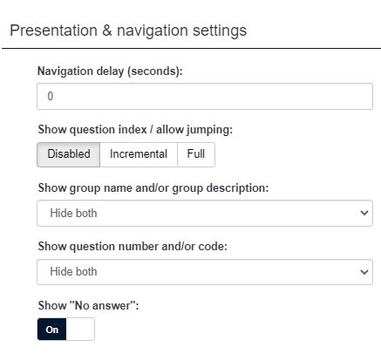**Navigation delay**: Number of seconds before Previous and Next buttons are enabled. Default 0 seconds.

**Show question index / allow jumping**:

* **Disabled** by default.
* **Incremental** means participants can jump to any question within the same group.
* **Full** means participants can jump to any section in the survey.

**Show group name and/or group description**:   
Controls the display of Group Names and Descriptions. Four Options:

* **Show both** (Default)
* **Show group name only**
* **Show group description only**
* **Hide both**

**Show question number and/or code**:

* **Show both** (Default)
* **Show question number only**
* **Show question code only**
* **Hide both**

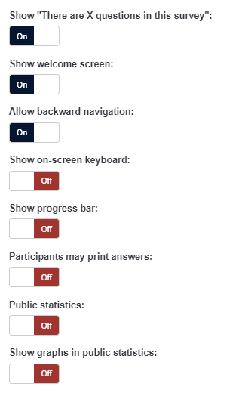**Show "No answer"**: Set to Off (Forced by system administrator).

**Show "There are X questions in this survey"**: On/Off. Default is On. If kept on, the message containing the number of questions will be displayed on the Welcome Screen.

**Show welcome screen**: On/Off.   
If On, the welcome message defined in Text Elements section will be displayed. Default is On.

**Allow backward navigation**: This option defaults to On; however if you set it to "Off" users will not have the option of moving to a previous page while completing the survey.

**Show on-screen keyboard**: By activating this setting there will be a virtual keyboard available for certain question types.

**Show progress bar**: On/Off. Default is On. Displays a progress bar so participants can see how much of the survey is remaining as they answer each question.

**Participants may print answers**: Default is Off. When it is set to On, a participant can print a summary of their responses when they submit.

**Public statistics**: Default is Off. If set to On, users who have submitted the survey will be presented a link to statistics of the current survey.

**Show graphs in public statistics**: Determines if public statistics for this survey include graphs or only show a tabular overview.

**Automatically load URL when survey complete**: Default is Off. If turned On, when the survey is submitted, it will automatically redirect the participant to the End URL specified in the **Text elements**.

## Publication & access control

These settings on this page are mainly to specify the start and end dates when you want the survey to be open for submissions.

From the **Settings** tab of the navigation pane, click **Publication & access** to open that section and view the options. All options are blank or OFF by default.

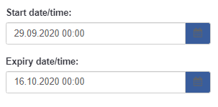**Start date/time**: Set this to the date and time when you want people to be able to start submitting responses. If people attempt to submit the survey before that date, they will get a warning message, letting them know it is nor open for submissions.

To disable, just clear the date from the field.

**Expiry date/time**: Set this to a specific date and time you want your survey to expire. To disable this just clear the date from the field.

|  |
| --- |
| **NOTE:** Even with the start date specified, the survey will not become active until you manually **activate** it. If there are no start or expiry dates, the survey will remain active for as long as you like, until you manually deactivate it. |

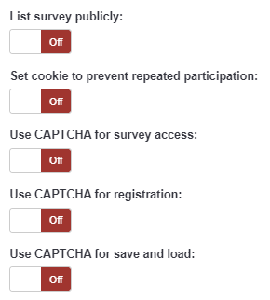**List survey publicly**: If set to On, your survey will be listed in the 'available surveys' portal, accessible to anyone from the page: <https://surveys.mcgill.ca/ls3>

**Set cookie to prevent repeated participation?** If set to On, a user working on the same computer will only be able to submit the survey once (unless they clear their browser cache and cookies).

**Use CAPTCHA for survey access**: Set to On if you want to display a text CAPTCHA to the user to ensure a real person is accessing the survey and not an automated script.

**Use CAPTCHA for registration**: If set to On, it asks the user to enter a CAPTCHA text before entering the Registration page.

**Use CAPTCHA for save and load**: Asks the user to enter a CAPTCHA text before Loading/Saving partial answers.

## Theme settings

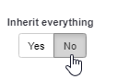On this page you can customize various options for the chosen theme, such as replacing the logo, using a different font or even applying advanced styles.

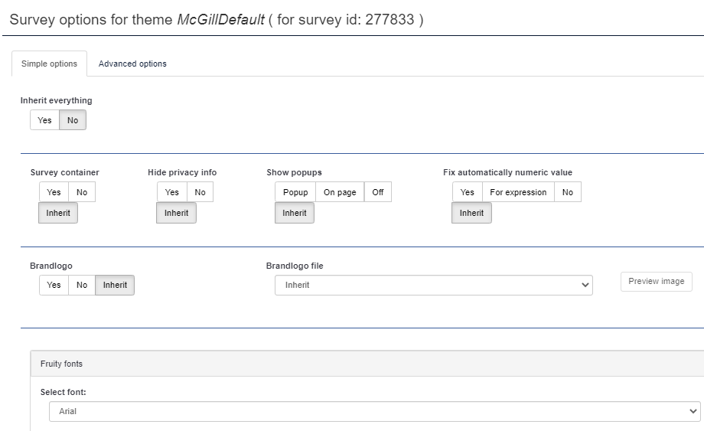In order to open up the options, you need to set the **Inherit everything** option to “No”.

## Notification & data management settings

These settings allow you to choose what information you want to be able to track about participation, so that you can analyse factors that may have affected your response rate.

From the **Settings** tab of the navigation pane, click **Notifications & data** to open that section and view the options:

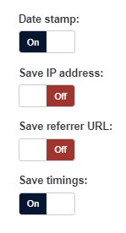

**Date stamp**: When turned On, the date and time are recorded for all survey responses.

**Save IP address**: When turned On, the IP address of the respondent is saved.

**Save referrer URL**: When turned On, it saves the URL from which the respondent was led to your survey.

**Save timings**: When turned On, it records the length of time a user stays on one page while completing the survey.

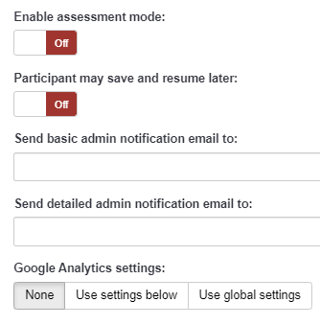**Enable assessment mode**: When turned On, the survey is treated as a quiz, which can be graded with correct/incorrect answers.

**Participant may save and resume later**: When turned On, it allows a participant to save his responses and resume to complete the survey later.

**Send basic /Send detailed admin notification email to:** Enter one or more email addresses (separated by semi-colon) if you want to send notifications whenever the survey is submitted.

**Google Analytics settings**: Google Analytics provides graphical data on the survey response rate and engagement, telling you when people came to the page, how long they stayed, where they came from and where they went afterward.

* + **None: No analytics performed**
  + **Use settings below: allows you to enter a Google Analytics Tracking ID.**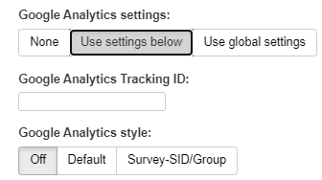
  + **Use global settings: Allows you to select the style for your Google Analytics report, but no tracking ID.**

## Participant settings (Tokens)

Tokens are used if you have a specific set of survey participants and you want to give each of them a unique URL to access the survey so that you can track their participation. The token is a random number appended to the URL and associated with a specific participant.

When tokens are used, you can import the list of participants and allow LimeSurvey to generate invitation and follow-up emails. Find out more about using tokens in Step 5) Invite participants.

|  |  |
| --- | --- |
|  | **TIP:** If you are planning to distribute your survey to a large audience, and you are not planning to track who has filled it out, you can skip this section. The default settings allow anonymized responses and no tokens. |

From the **Settings** tab of the navigation pane, click **Participant settings** to open that section and view the options:

**Set token length to:** This field allows you to set the number of characters used for each unique token. The default length is 15.

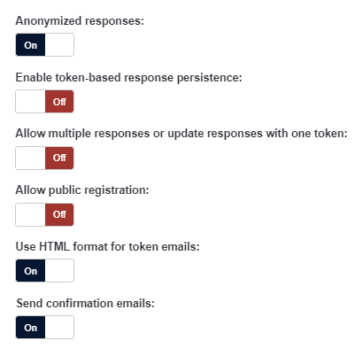**Anonymized responses:** When tokens are used to control survey access, this setting allows you to determine whether responses are matched up with information from your survey’s tokens table, or kept anonymous.

**Enable token-based response persistence**: When turned On, it allows the participant to resume after partially completing the survey.

**Allow multiple responses or update responses with one token:** If turned On, participants may return to his survey by clicking the invitation link, even if they have already submitted the survey. This only works when **Anonymized responses** is set to Off.

**Allow public registration:** When turned On, it allows anyone to complete the survey, while maintaining the use of tokens.

**Use HTML format for token emails:** When turned On, it allows your invitation email to contain HTML formatting.

**Send confirmation emails:** When turned On, a confirmation email is sent to the participant after submitting the survey.

# Step 3) Add and edit questions

Survey questions are organized into **groups**. Each question must be a member of a **group** (and only that **group**). Depending on the number of questions in the survey, **groups** can be used to define logical sections, common subject themes, or pages on the screen. A group can have questions about a similar subject or simply be set up as a manageable number of questions.

A question **group** has a **Title** and an optional **Description**. You must have at least one **group** in each survey, even if you do not wish to divide the survey into multiple groups.

## [Creating a question group](http://docs.limesurvey.org/Creating+a+question+group&structure=English+Instructions+for+LimeSurvey)

1. Click on the **Structure** tab in the left navigation panel.
2. Then click **Add question group**.  
   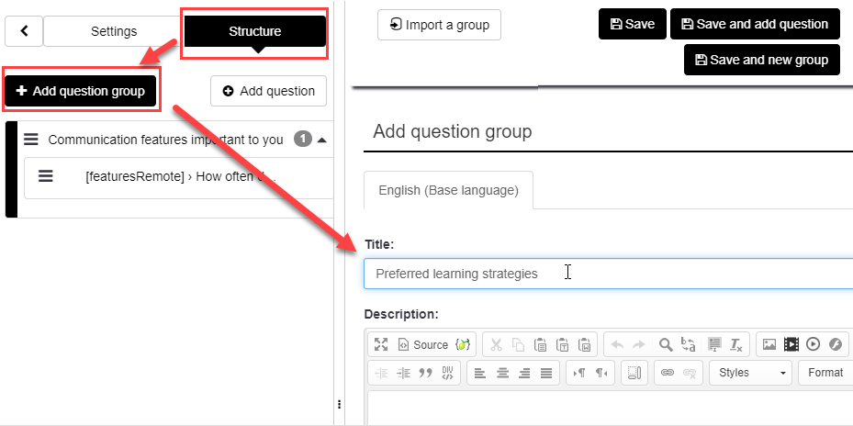
3. Enter a **Title** (required) and a **Description** (optional) for the group. You may use the HTML editor for the description to include images, formatted text, etc.  
     
   NOTE: The group title and description can be displayed or hidden, depending on your selection in the **Presentation and navigation settings** page (accessed from the **Settings** tab).

## Editing or deleting a question group

From the **Structure** tab on left side navigation panel, click on the group name. In the top menu of the page you can do the following:  


* **Preview survey** – Verify how participants will view and interact with the survey.
* **Preview question group** - Verify how participants will view and interact with this group of questions.
* **Edit current question group** - Make changes to the group title and/or description
* **Delete current question group** - Remove the entire group and all questions (including sub-questions and answer options).
* **Export this question group** – Export the entire question group to a file that you can then import into another survey.
* **Check survey logic for current question group** – Verify if there are errors in any of the conditions you have set within the group.

## [Adding question](http://docs.limesurvey.org/Adding+a+question&structure=English+Instructions+for+LimeSurvey)s

**Questions** are the core of your survey. There is no limit to the number of **questions** you can have in your **survey** or in a **group**. **Questions** include the actual question text, sub-question text, answer options, as well as settings that determine how the question will be displayed and how results will be stored.

You can also specify a short 'help' explanation for each question and determine whether the question is mandatory or optional.

To add a new question:

|  |  |
| --- | --- |
| 1. From the **Structure** tab on the navigation panel, page, select a question group and click **Add question**.   OR   Click **Add new question to group** on the **Group summary** page or on the **Question summary** page. |  |
| 1. Enter the basic attributes: |  |

* 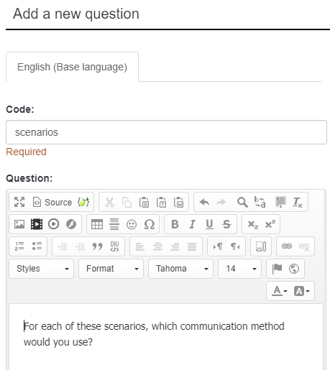**Code:** Enter a unique code for the question, starting with a letter and containing no spaces. This code will be used to identify the question when exporting the survey structure, or the results. It is not displayed to participants taking the survey.
* **Question:** This is the question that will appear on screen. You can use the WYSIWYG editing controls to change the text style, size and color, or add images if needed.
* **Help:** This is an optional field. It is useful if you want to provide additional instructions for how to answer the question.   
     
  NOTE: LimeSurvey provides automatic hints based on the question type you select; for example, “Choose all that apply” is the default hint for multiple choice questions. You can turn off these automatic hints and use the Help field to provide your own personalized instructions

1. Choose a question type

[There are many question types](http://docs.limesurvey.org/Question+types&structure=English+Instructions+for+LimeSurvey) available**.** Click the button showing the current **Question Type** to open the **Select question type window**.

In this window you can preview how each question type will look before you make your decision.   
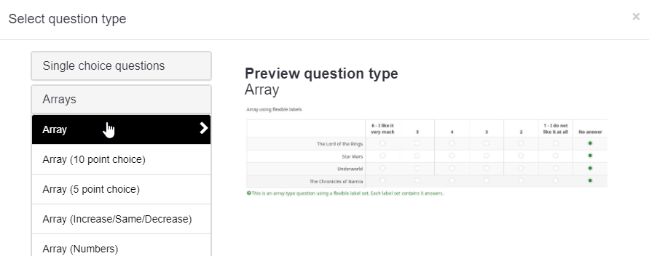

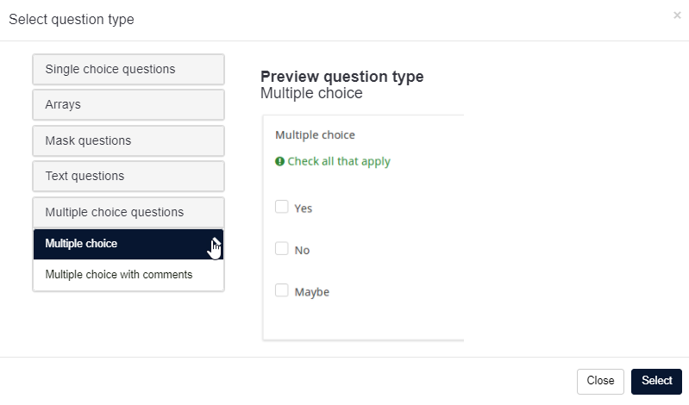

* [**Single choice questions**](http://docs.limesurvey.org/Question+types&structure=English+Instructions+for+LimeSurvey#Single_choice_questions)
  + [5 point choice](http://docs.limesurvey.org/Question+types&structure=English+Instructions+for+LimeSurvey#point_choice)   
    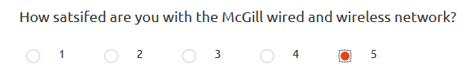
  + [List (Dropdown)](http://docs.limesurvey.org/Question+types&structure=English+Instructions+for+LimeSurvey#List_Dropdown_)   
    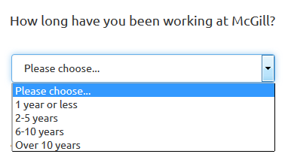
  + [List (Radio)](http://docs.limesurvey.org/Question+types&structure=English+Instructions+for+LimeSurvey#List_Radio_)   
    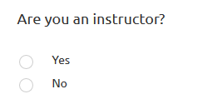
  + [List with comment](http://docs.limesurvey.org/Question+types&structure=English+Instructions+for+LimeSurvey#List_with_comment)
* [**Array**](http://docs.limesurvey.org/Question+type+-+Array&structure=English+Instructions+for+LimeSurvey): Arrays allow you to display a matrix, in which each row represents a different sub-question or item, and the answer options, labeled at the top, are available for each item.

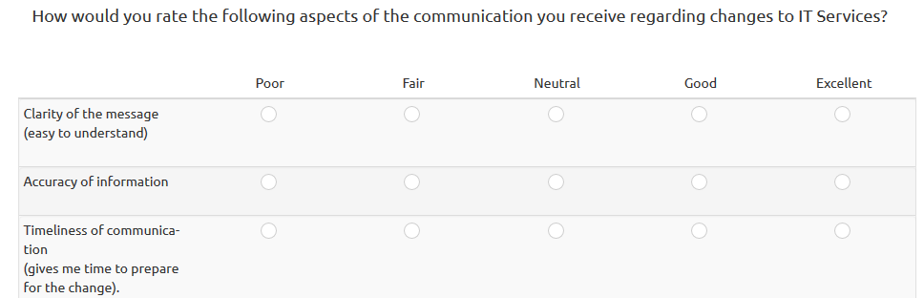

* [**Mask questions**](http://docs.limesurvey.org/Question+types&structure=English+Instructions+for+LimeSurvey#Mask_questions)
  + [Date](http://docs.limesurvey.org/Question+types&structure=English+Instructions+for+LimeSurvey#Date)
  + [File upload](http://docs.limesurvey.org/Question+types&structure=English+Instructions+for+LimeSurvey#File_upload)
  + [Gender](http://docs.limesurvey.org/Question+types&structure=English+Instructions+for+LimeSurvey#Gender)
  + [Language switch](http://docs.limesurvey.org/Question+types&structure=English+Instructions+for+LimeSurvey#Language_switch)
  + [Numerical input](http://docs.limesurvey.org/Question+types&structure=English+Instructions+for+LimeSurvey#Numerical_input)
  + [Multiple numerical input](http://docs.limesurvey.org/Question+types&structure=English+Instructions+for+LimeSurvey#Multiple_numerical_input)
  + [Ranking](http://docs.limesurvey.org/Question+types&structure=English+Instructions+for+LimeSurvey#Ranking)
  + [Text display](http://docs.limesurvey.org/Question+types&structure=English+Instructions+for+LimeSurvey#Text_display)
  + [Yes/No](http://docs.limesurvey.org/Question+types&structure=English+Instructions+for+LimeSurvey#Yes_No)

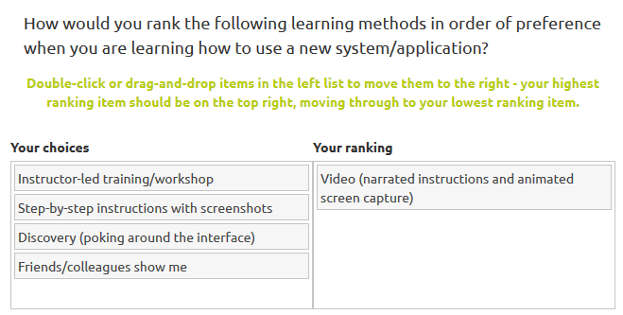

* [**Multiple choice questions**](http://docs.limesurvey.org/Question+types&structure=English+Instructions+for+LimeSurvey#Multiple_choice_questions)
  + [Multiple choice](http://docs.limesurvey.org/Question+types&structure=English+Instructions+for+LimeSurvey#Multiple_choice)
  + [Multiple choice with comments](http://docs.limesurvey.org/Question+types&structure=English+Instructions+for+LimeSurvey#Multiple_choice_with_comments)

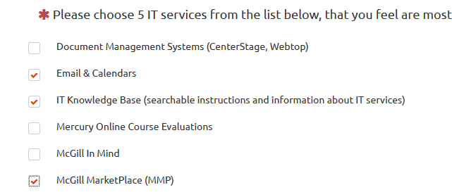

* [**Single choice questions**](http://docs.limesurvey.org/Question+types&structure=English+Instructions+for+LimeSurvey#Single_choice_questions)
  + [5 point choice](http://docs.limesurvey.org/Question+types&structure=English+Instructions+for+LimeSurvey#point_choice)
  + [List (Dropdown)](http://docs.limesurvey.org/Question+types&structure=English+Instructions+for+LimeSurvey#List_Dropdown_)   
    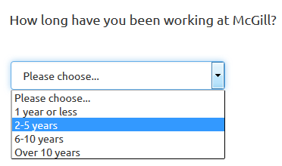
  + [List (Radio)](http://docs.limesurvey.org/Question+types&structure=English+Instructions+for+LimeSurvey#List_Radio_)
  + [List with comment](http://docs.limesurvey.org/Question+types&structure=English+Instructions+for+LimeSurvey#List_with_comment)
* [**Text questions**](http://docs.limesurvey.org/Question+types&structure=English+Instructions+for+LimeSurvey#Text_questions)
  + [Huge](http://docs.limesurvey.org/Question+types&structure=English+Instructions+for+LimeSurvey#Short_free_text) free text
  + [Long free text](http://docs.limesurvey.org/Question+types&structure=English+Instructions+for+LimeSurvey#Long_free_text)
  + [Multiple short text](http://docs.limesurvey.org/Question+types&structure=English+Instructions+for+LimeSurvey#Multiple_short_text)
  + Short free text  
    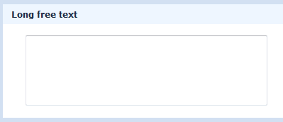
* **Question group: You can select any group for the question. However, beware of switching questions between groups if you have conditional logic in your survey.**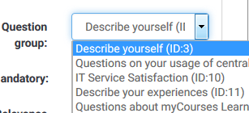
* **Option ‘Other’:** If you select a question type that contains options(i.e., single-select list or multiple select list), you can allow participants to select ‘Other’ and enter their own text.   
  
* **Mandatory:** Turning On this setting allows you to require users to answer the question, before they can move on to the next page of the survey. For ranking question Mandatory means all items have to be ranked.   
  

## Question options

At the right side of each question edit page, there are collapsible panels for: General options, Display, Logic, Other and Statistics.

The options within each section vary depending on the type of question. Below, the descriptions provided give you an idea of what you might find useful for commonly used question types.

### General options

Here you will be able to choose the question type, choose the question group it belongs to (by default it is the group you had last selected), and choose the position where it will appear within that group.

Relevance is another general option, which is set to 1 by default. If you have specified conditions for this question, the relevance field will be different; see Setting conditions, below.

### Display

These settings allow you to specify visual/interaction options. Here are a few examples:

**Use slider layout** - allows you to choose sliders or stars for questions of type 5-point choice.  
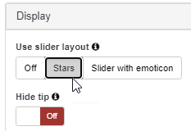 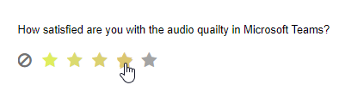  
  
**Category separator** is a display option used with List type questions. It allows you to enter a separator character if your options are grouped. You can then insert this character into each of your answer options. In the example shown below, groupings of operating systems are separated using the colon “:” character as the category separator.

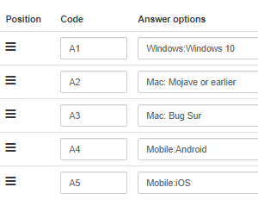 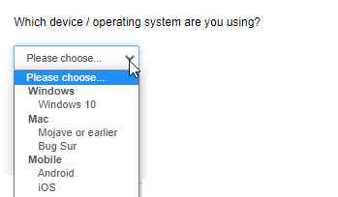

For additional details, see the [LimeSurvey User Manual](https://manual.limesurvey.org/QS:Category_separator) online.

### Input

For question types that require the user to enter text or numeric data, this section contains options for restricting the length, min/max value or type of data they enter.

### Logic

This section contains options for dealing with the response. For example, if you are creating a survey with assessment questions, you can specify which values correspond to ‘Correct’ answers and provide feedback to users depending on what they enter. For array questions, where there are several sub-questions, you can specify a minimum or maximum number of answers that can be selected.

|  |  |
| --- | --- |
|  | **TIP:** Preview the question to view the automatic hints that appear based on your logic specifications. |
|  | |

### Statistics

This section allows you to display the current results to participants if you wish. If you turn **Show in public statistics** On, and **Display chart** is On, you can choose what **Chart type** to display (Bar, Pie, Line, etc.)

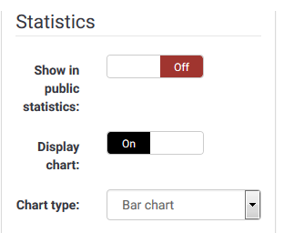

## [Adding answer options and sub-questions](http://docs.limesurvey.org/Adding+answers+or+subquestions&structure=English+Instructions+for+LimeSurvey)

Various question types, such as multiple-choice questions and arrays, require you to add a list of answer options and/or sub-questions.

To add answers to one of these question types click on the "**Edit answer options**” button at the top of the **Question summary** page.  
 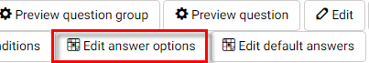.  
  
When adding an answer you will be asked for an "Answer Code" and an "Answer”.

1. **Answer code:** This is the data that will usually be exported to your spreadsheet when compiling results. You may choose whatever code you want (5 character maximum). The code can only contain standard alpha-numeric characters.
2. **Answer:** The answer that will be displayed.
3. **Position:** Click and drag the cross-hair icon beside each answer option to change its position in the list.

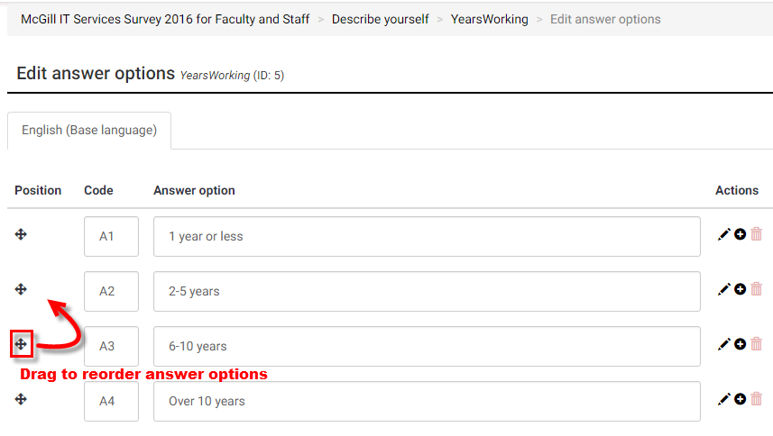

1. **Default:** To set a default answer for the question, click on the "**Edit default answers**” button at the top of the **Question summary** page.

If you choose a default answer the survey result will record that value if the participant does not change it to something else.  
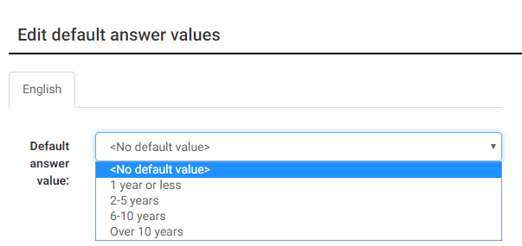

## Reorder groups or questions within a group

1. From the **Settings** tab on left side navigation panel, scroll down to the **Survey menu** and click **Reorder questions /question groups**:  
   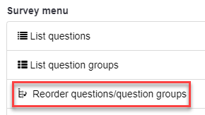
2. On the **Organize question groups/questions** page you can reorder groups or individual questions by clicking and dragging their titles to the desired position.  
   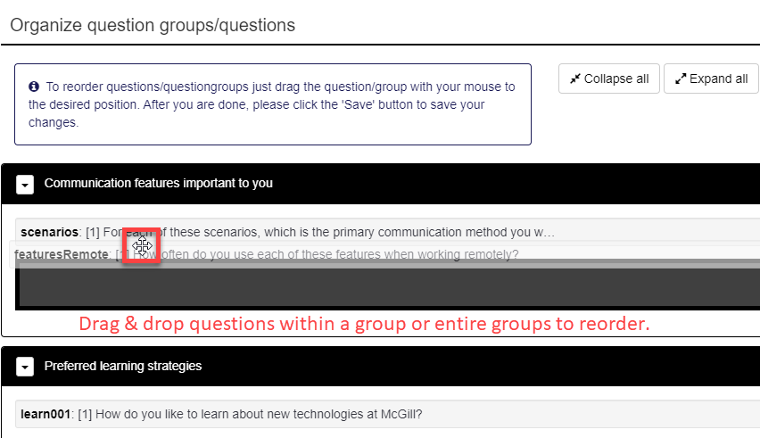
3. Click **Save** at the top of the page when you are done.

## [Setting conditions](http://docs.limesurvey.org/Setting+conditions&structure=English+Instructions+for+LimeSurvey)

By default, all questions in a survey are displayed. However, you may want to show or hide questions depending on how a participant responds to previous questions.

You do this by setting up a condition or set of conditions on the question(s) that you want to show or hide.

### Setting a simple condition for a question

1. From the navigation panel by clicking **Questions and groups > Question explorer**.
2. Click on the question that you want to show or hide (depending on responses to previous questions in the survey).
3. Click **Set conditions** from the menu at the top of the question page to open the **Conditions designer** page.

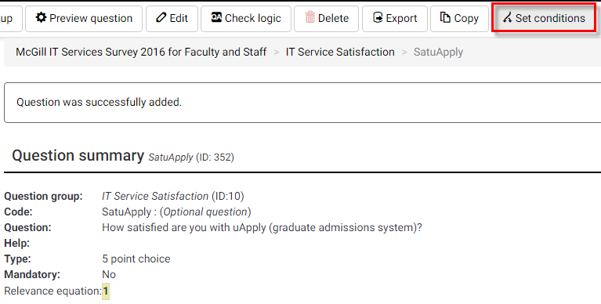

1. In the **Add condition** section the most common type of condition is based on **Previous questions** – where the conditional display of the current question is based on the participant’s answer to a prior question in the survey.
2. Select the **Previous questions** tab; then select the question or sub-question that the condition is based on.  
   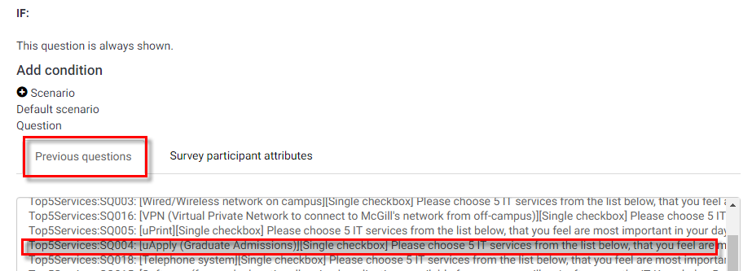
3. Choose the **Comparison operator** (equals, not equal to, etc.).  
   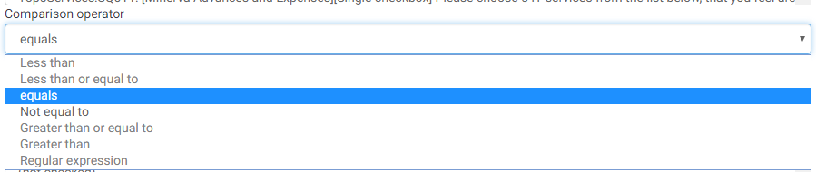
4. Then choose the **Answer** option that corresponds to the condition on which the question will be displayed.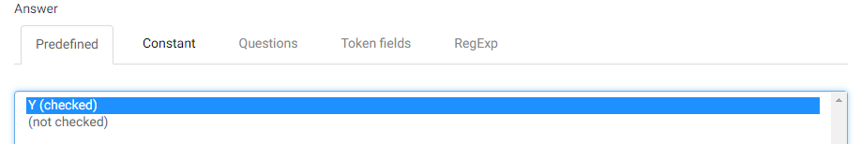
5. Click **Add condition**, at the bottom to save it.   
   The condition will appear at the top of the page.

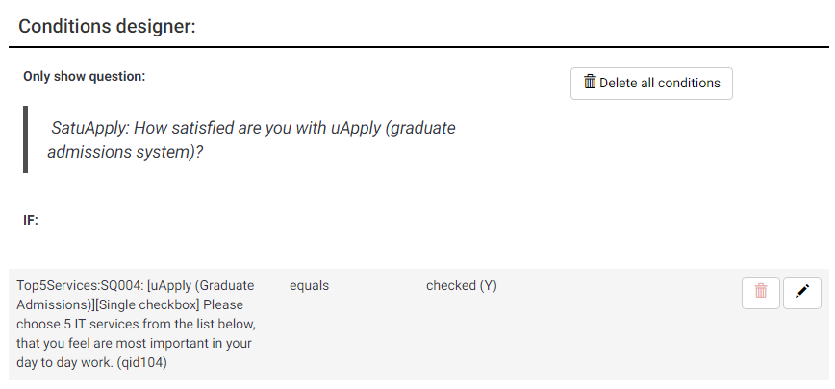

1. Click the **Close** button at the top to return to the **Question summary** page.

**NOTES:** You may also specify conditions based on attributes of the person filling out the survey. To do so, select **Survey participant attributes**. Then select the attribute for the condition, the comparison operator and the value to compare.

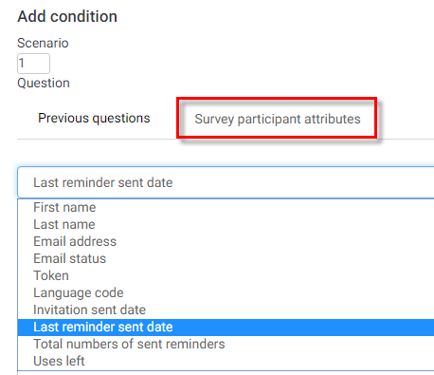

You can add multiple conditions for the same question if needed.

|  |  |
| --- | --- |
|  | **TIP:** When using conditions, it is recommended to test/preview your survey flow with all response combinations to make sure your conditions are working as expected. |

### Setting conditions on a question group

Your survey may need to show or hide a whole group of questions, based on participants’ responses to previous questions. For example, some surveys require participants to click “Yes” on a privacy agreement before having access to the remaining survey questions.

There is no direct way to set up a condition on a question group. However, you can achieve the same result by following these steps:

1. Select the first question in the group that you want to be able to show or hide, and set up the condition on that question (by following the steps for a simple condition, above).
2. When you close the set conditions window, you will see that the **Relevance equation** for that question now has a conditional statement on it, as shown below.
3. Copy that **Relevance equation** from the **Question**.

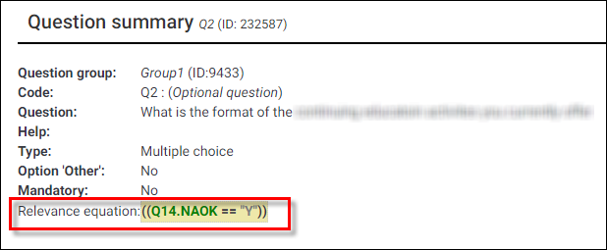

1. From the **Question explorer**, click the **Group summary** icon, next to the question group that you want to show/hide.  
     
   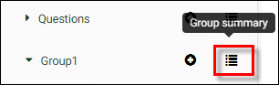
2. Click **Edit current question group**, at the top of the page and paste the condition you copied into the Relevance equation box for that group.  
     
   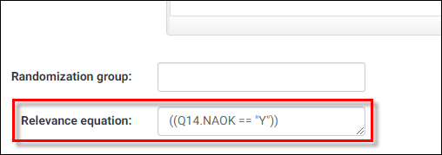

Now the condition will apply to the entire group of questions.

1. Test your survey to make sure it behaves as desired.

|  |
| --- |
| **NOTE:** For additional information about conditions, see the LimeSurvey user manual at: <https://manual.limesurvey.org/setting_conditions/en> |

## Quotas

If you want to limit your survey to a specific number of people, you can create a quota. You can also put a quota on the number of participants who respond with specific answers to a question.

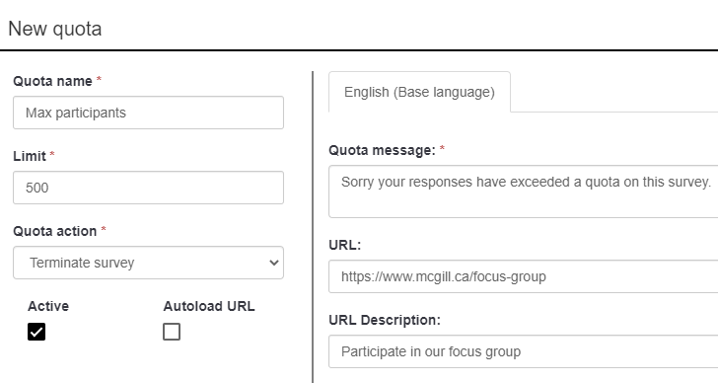

# [Step 4) Preview the survey or questions](http://docs.limesurvey.org/Managing+Surveys&structure=English+Instructions+for+LimeSurvey)

Preview the survey, a question group or an individual [question](http://docs.limesurvey.org/Question+preview&structure=English+Instructions+for+LimeSurvey)

### Preview survey

To preview the entire survey, click the **Preview survey** button at the top of almost any page.  
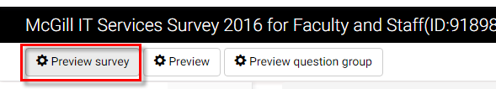

### Preview question group

Click **Preview question group** at the top of the **Group summary** page, or at the top of any question page.

### Preview question

To preview a question, click **Preview Question** at the top of the **Question summary** page.

# Step 5) Manage participants

## Initialize the participant table

The participant table allows you to specify unique tokens for each participant. This ensures that the participant will only fill out the survey once. In addition, the master survey for continuing studies is set up to ensure anonymity of participants, so the tokens and participants table are not associated with the survey results.

1. From the Survey home page, click **Survey participants**.  
   
2. When prompted click **Initialise participant table**. This creates an empty table with all the columns needed to track participation.
3. Click **Display** **participants** to view the empty table.  
   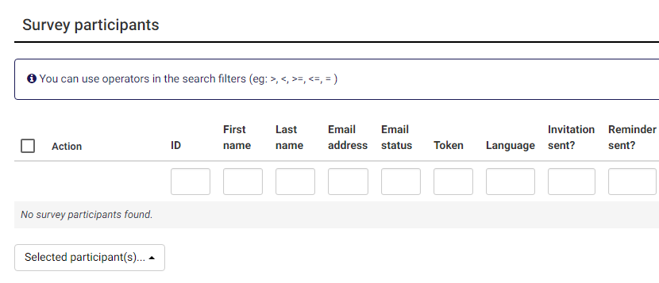

## Import a list of participants

You can create a list of participants in Excel or a .CSV text file and import it into LimeSurvey.

1. Create an Excel file with column headings “**firstname**”, “**lastname**” and “**email**” (no spaces or capitalization) containing the corresponding values for each participant. You don’t need any other columns.  
   
2. Save the Excel file in **CSV format** (comma separated values).
3. In LimeSurvey, from the **Participants** menu, click **Create >** **Import participants from** > **CSV file**.   
   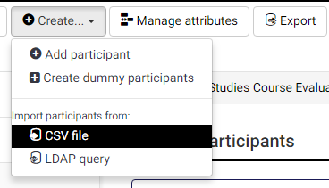
4. On the Import screen, click **Choose File**, and select the CSV file containing your participant list.  
   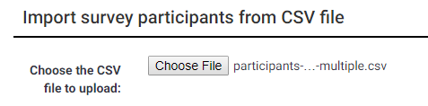

Click **Upload**. If there are no errors, you should see a message telling you how many new records were created.

|  |
| --- |
| **NOTE:** You can upload additional participants and the new ones will be appended to the existing participant table. |

1. Click **Browse participants** to view them and spot check that the names and email addresses appear correctly.

## Generate tokens for participants

1. Click **Generate tokens** at the top of the Participants page. This will generate a unique code for each participant row, which will be appended to the URL of the survey when the invitations are sent,  
   
2. If you click **Display participants**, you should now see that each one has a unique **Token** in the table.  
   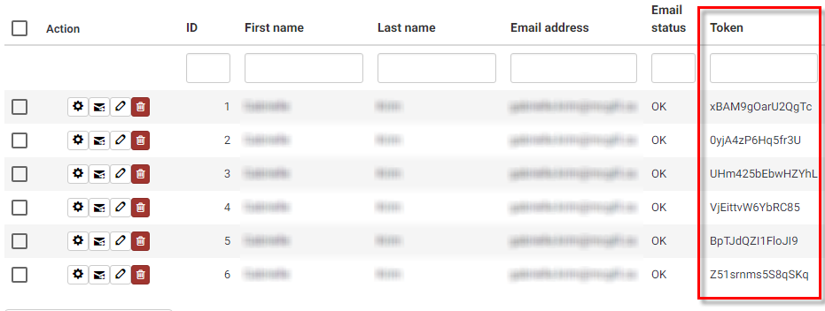

# Step 6) [Activate your survey](http://docs.limesurvey.org/Activating+a+survey&structure=English+Instructions+for+LimeSurvey)

## Activate the survey

Once you are happy with the structure of your survey you can activate it by clicking **Activate this survey**, from the Survey homepage.  
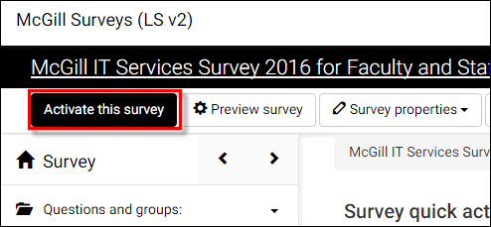

|  |
| --- |
| **Before you activate a survey, note the following:**   * Once the survey is activated, you can change the text of questions and answers, or general text that appears on the survey, but you cannot change a question or answer type. * You cannot add or delete questions. * You cannot add answers to any of the array or multiple-choice questions - however you can add answers to the basic list type questions. |

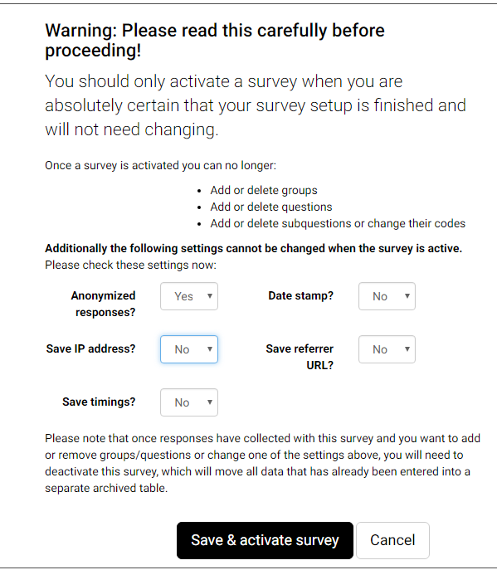

You will be prompted to verify the survey settings which cannot be changed.

Click **Save & activate survey** when you are ready to make it live.

# **Step 7) Invite participants**

## Open, anonymous surveys

If your survey is open to a large audience, and you do not plan to manage each participant individually, you can just send out the general survey URL(s) to all participants and/or post the links on a public web page or announcement.

Survey URL(s) are listed on the home page of the survey; there are separate URLs for each language you have specified.   
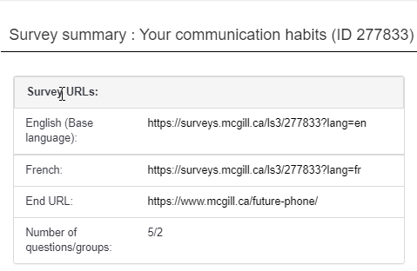

**NOTE:** If your survey is multi-lingual you need to create the questions in each language via tabs at the top of each question.

## Invitations for managed participants

If you are using a participant list (see Step 5) Manage participants), it is easy to use LimeSurvey to send out the invitations, follow-up reminders and confirmations.

### Edit invitation email templates

LimeSurvey has default email templates, but you will likely want to personalize them for your audience and purpose.

1. Go to the **Settings** tab of the navigation pane and click **Email templates** to access the various email templates, which you can modify to your needs.
2. On this page you can select email template you want to edit: Invitation, Reminder, Confirmation, Registration, as well as email notifications sent to the survey administrators.   
   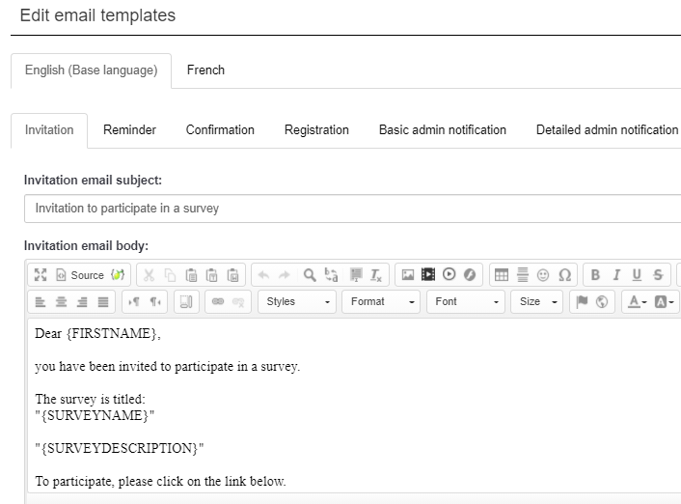  
     
   Enter your text in the message body and use the WYSIWYG menu bar to style your text. You can even add an attachment file, if needed.  
     
   Do not edit the text in curly braces: {FIRSTNAME}, {SURVEYNAME}, {SURVEY DESCRIPTION} These are keywords that will be replaced by data specific to your survey.

Send email invitations to your participant list

If you have set up a participant list with names and email addresses of everyone you want to invite, and you have edited the invitation email template, and if your survey has been activated, you can send out the email invitations.

1. Go to the **Survey participants** page.
2. The **Survey participant summary** table will indicate the total number of participant records and information about which emails have been sent to them.
3. At the top of the page, click **Invitations & reminders > Send email invitation**.  
     
   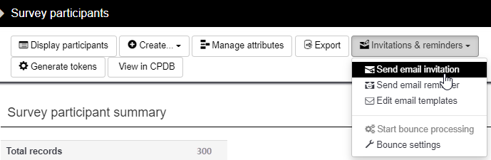

# Step 7) Analyse survey results

## [Browse survey results](http://docs.limesurvey.org/Browsing+survey+results&structure=English+Instructions+for+LimeSurvey)

When your survey is active, the top menu bar options change.



You will now see a menu named **Responses**, which contains options to view the Responses that have been submitted.

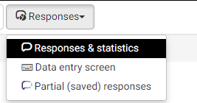

1. Click **Responses & Statistics**. The Response summary screen opens and displays the following information:

* The total number of full responses received (submitted)
* The total number of incomplete responses recorded
* The total number of responses recorded (full response and incomplete responses)

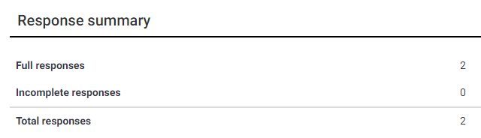

## View survey results

In order to view individual participant responses click the “**Display responses**” from the menu.

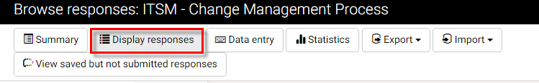

You will see a table with all participant responses for all questions.

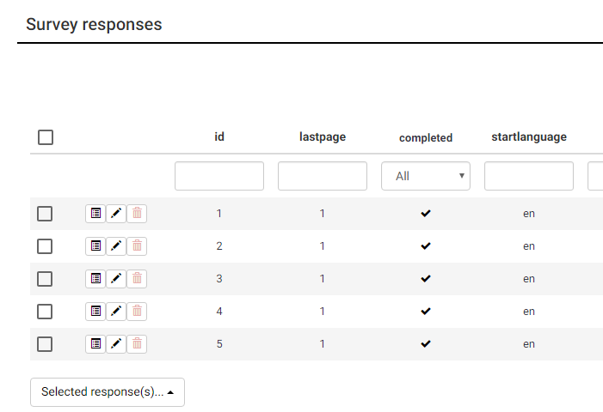

You can use the dropdown list under the **completed** column to view **All** responses or only those completed (**Yes**), or not completed (**No**).

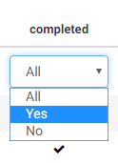

To view an individual participant’s responses, click the “**View response details**” icon on the row corresponding to the participant.



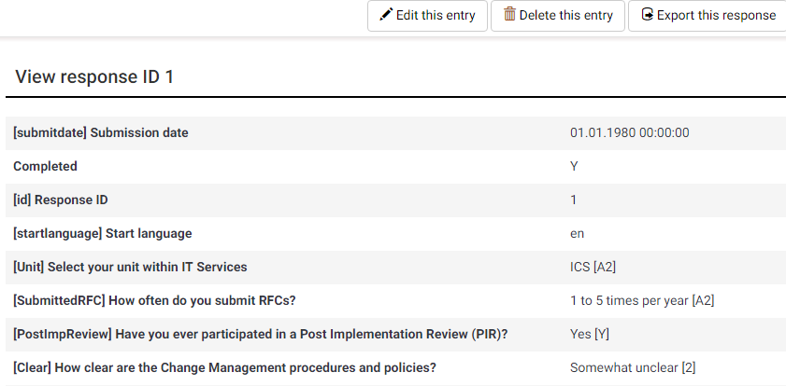

View Statistics

From the **Responses and Statistics** page, click **Statistics.**

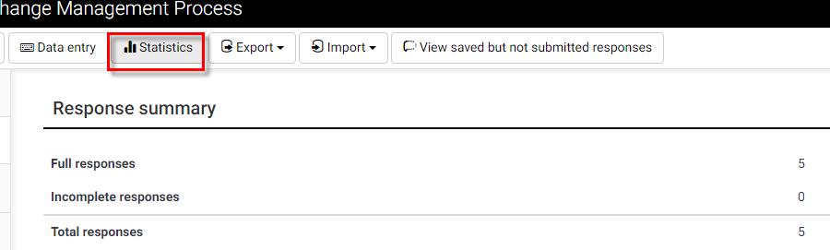

By default, you enter **Expert mode**, where you have options to filter the data and display it as you wish.

### General filters

Under **General filters,** there are many options for displaying the responses.

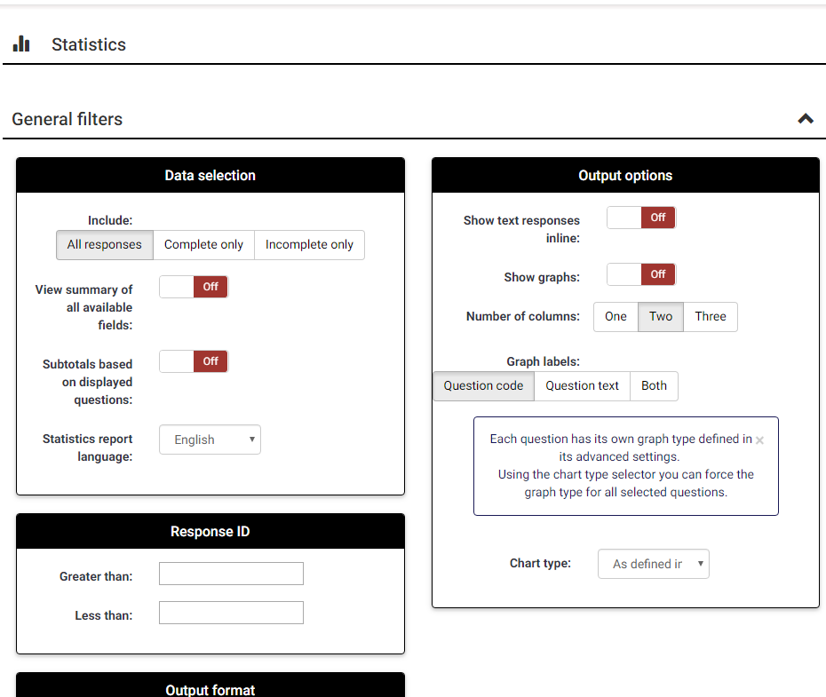

**Data selection:** Allows you to filter the data to display based on the completeness of responses, elect to view a summary of fields subtotals.

**Response ID:** Allows you to specify a range of IDs to include – only applies if your participants are given unique IDs.

**Output format:** HTML, PDF, Excel

**Output options:** Show text responses inline (as opposed to a separate table), Show graphs [On/Off], Graph labels (Question code, Question text or Both) Chart type (select from a variety of styles).

### Response filters

In this section, you can filter which responses to include in your analysis. Hold down the **Ctrl** key to select/de-select multiple options in each response list.

## View and interact with statistics

Once you have specified the data you want to view, click **View statistics** to view the resulting analysis.

If you turned **Show graphs** ON under **Output options**, you will see one chart for each question, corresponding to your selections on the **Response Filters** section.

### Interact with charts dynamically

Click the buttons at the bottom of a chart to change the type. 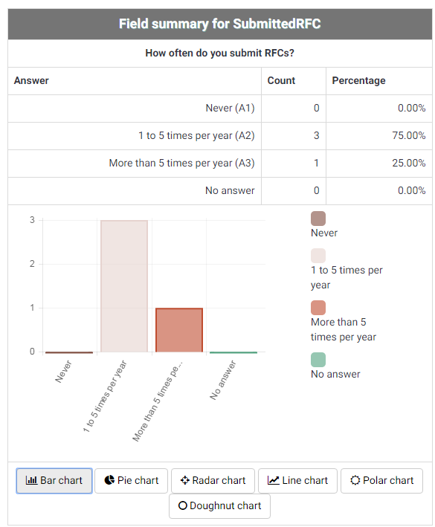

Click on a data point/bar/pie wedge to view details about it.

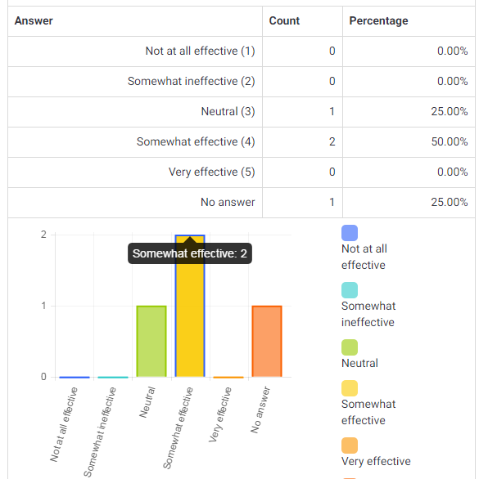

### Simple mode

Click **Simple mode** on the **Statistics** page to get a quick overview of responses.



A simple bar graph is displayed for each question.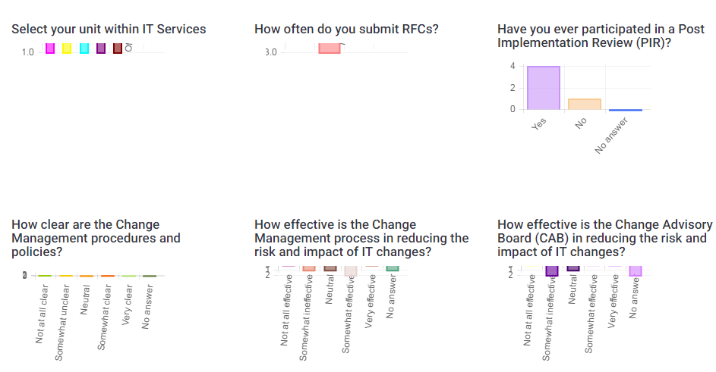

[Close a survey](http://docs.limesurvey.org/Closing+a+survey&structure=English+Instructions+for+LimeSurvey)

There are two ways for closing a survey: Expiration or Deactivation.

### Expiration

Within the **Survey Settings** > **Publication & access control** section, you can set an "**Expiry date/time"**. The survey will automatically close on that date.

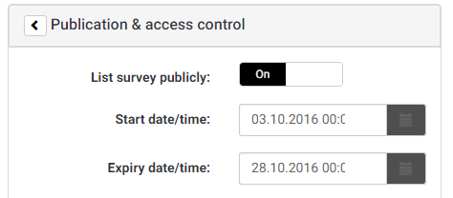

### Deactivation (stopping the survey manually)

From the survey homepage, click **Stop this survey** in the menu at the top.

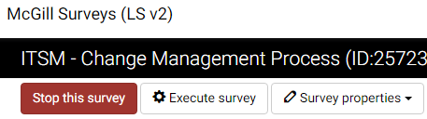

After clicking **Stop this survey**, you will be prompted to choose between **Expire survey** and **Deactivate survey** options.

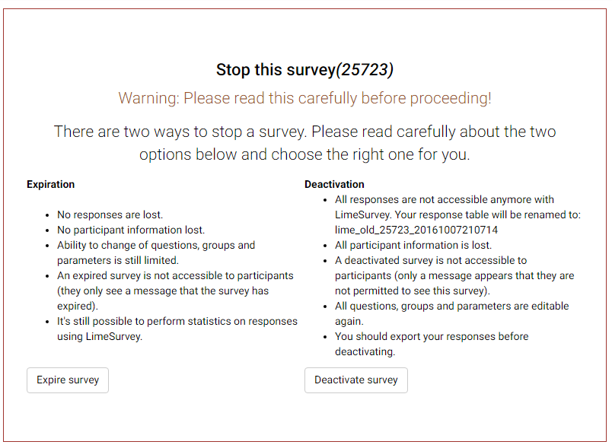

|  |
| --- |
| **IMPORTANT: Once the survey is Deactivated, all results are no longer accessible through LimeSurvey, and all participant information is lost. Therefore, it is critical to export and save your data before deactivating the survey.** |

## 

## [Exporting results](http://docs.limesurvey.org/Exporting+results&structure=English+Instructions+for+LimeSurvey)

At any point while your survey is active, or if it is expired, you can view and export the responses.

* + - 1. Click **on Responses and choose** **Responses & Statistics** from the Survey menu bar. 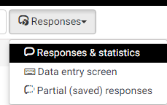
      2. Click the **Export** menu and select one of the export methods:

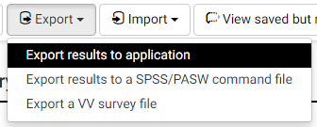

### Export results to Excel

1. From the top of the **Responses & Statistics** page, click **Export** > “**Export Results to application**”.

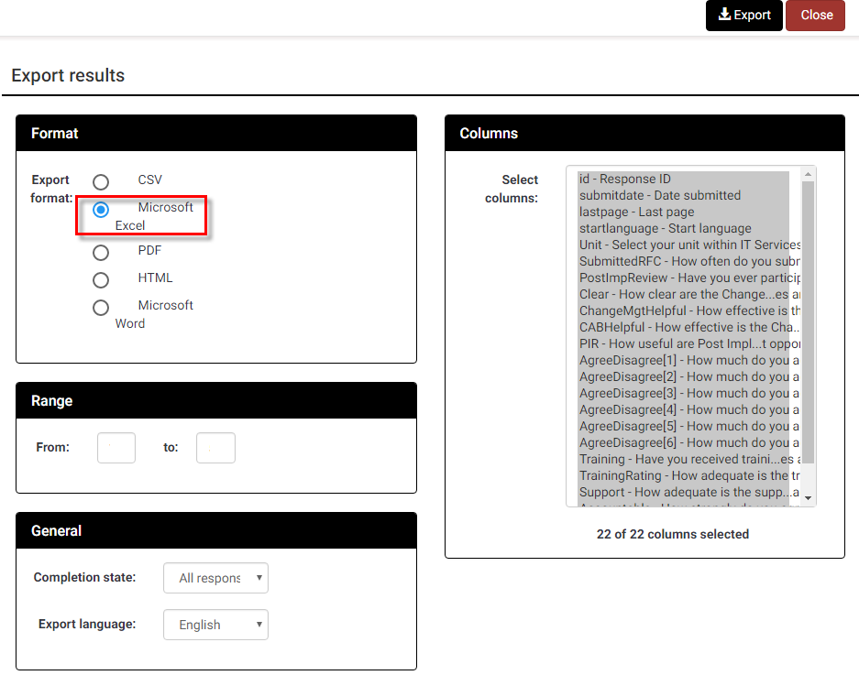

Fill it out the options on this screen according to the information you would like to capture in the Excel table:

* **Export format:** Choose **Microsoft Excel** if you want to view and manipulate the date with Excel. You can also choose PDF, HTML, CSV or Microsoft Word.
* **Range:** Select the range of questions you want to appear (the default is all questions)
* **Completion State:** Select from “All responses”, “Completed responses only” or “Incomplete responses only”
* **Export language:** Applies to surveys that are made available in multiple languages.
* **Headings:** Select how you would like the column headings to display. Choices include: “Question code”, “Abbreviated question text”, “Full question text”” or “Question code and question text”.
* **Responses:** Select how you would like the answers to display. Choices include: “Answer codes” or “Full answers”. If you want answer codes to be displayed you can set whether you want Y and N answers to appear as 1 and 2.
* **Columns:** Choose the columns you would like to appear in the file. All data is selected as the default. Use the CTRL key to select specific columns.

Click **Export** at the top of the window. Data will be exported to the chosen file format, and will be downloaded by your web browser, to your default downloads folder.

Depending on your web browser settings you may be prompted to save it in a location of your choice or open it directly in the application you selected.

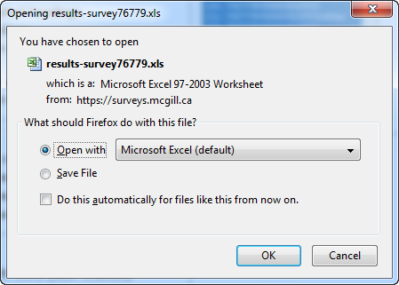

### Exporting survey data in SPSS

From the Reponses and Statistics page, click Export > Export results to a SPSS/PASW command file.

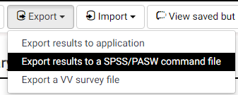

The following screen will appear:

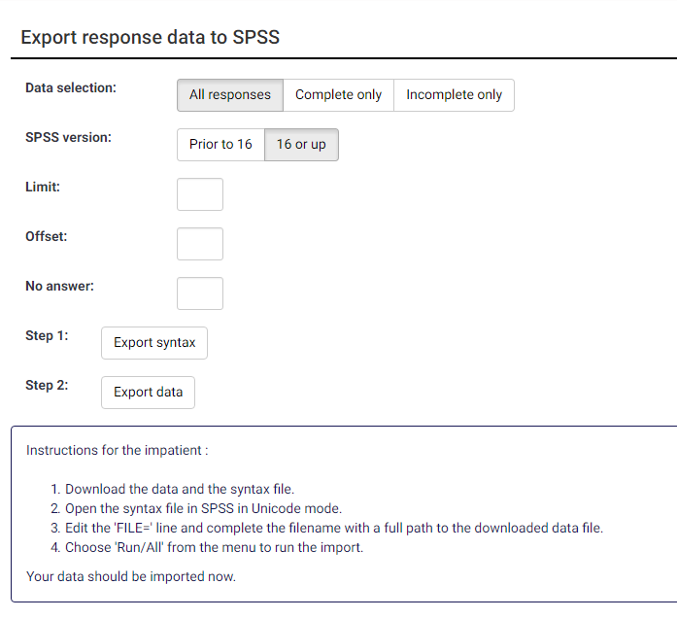 Top of Form

Fill out the following fields:

* **Data selection:** Select from “All responses”, “Completed responses only” or “Incomplete responses only”
* **SPSS version:** Choose whether you are using version” 16 or up” or “Prior to 16”
* Click “**Export Syntax**” and “**Export Data**” to download the data and the syntax file.

Follow the instructions displayed on screen:

1. Download the data and the syntax file,
2. Open the syntax file in SPSS in Unicode mode.
3. Edit the “FILE=” line and complete the filename with a full path to the downloaded data file.
4. Choose 'Run/All' from the menu to run the import.

Your data will now be imported.