LimeSurvey   
User Guide to

Creating Surveys

Created: October 7, 2016

Last updated: January 22, 2019

Contents

Gaining access to LimeSurvey 4

Importing an existing survey from the old LimeSurvey 4

Export survey from previous version 4

Import an existing survey from .lss file 5

Accessing your survey 7

Survey Settings: 9

Edit Text Elements: 9

General options: 10

Presentation & navigation 11

Publication & access control 12

Notification & data management 13

Tokens 14

Question Groups 15

Creating a question group 15

Editing or deleting a question group 17

Adding questions 18

To add a question: 18

Question fields: 19

General options 20

Question type: 20

Advanced settings 24

Display 24

Input 24

Logic 25

Statistics 25

Adding answers or sub-questions 25

Reorder groups or questions within a group 27

Setting conditions 28

Setting a simple condition for a question 28

Setting conditions on a question group 31

Managing Surveys 33

Preview the survey, a question group or an individual question 33

Preview survey 33

Preview question group 33

Preview question 34

Activate a survey 35

Browse survey results 36

View survey results 37

View Statistics 39

General filters 39

Response filters 41

View and interact with statistics 41

Interact with charts dynamically 41

Simple mode 42

Close a survey 43

Expiration 43

Deactivation (stopping the survey manually) 43

Exporting results 45

Export results to Excel 45

Exporting survey data in SPSS 47

# Gaining access to LimeSurvey

If you have never used McGill’s LimeSurvey tool, you will need to request access.

* Contact [ITSupport@mcgill.ca](mailto:ITSupport@mcgill.ca) to request access to LimeSurvey and to have a survey created.
* Once you have been granted access, you will receive an email with instructions on how to log in. Go to [https://surveys.mcgill.ca/ls/index.php/admin](https://surveys.mcgill.ca/ls/index.php/admin/) and enter your McGill Username and the password you were given for the site (note that you can change your password if desired).
* Select your survey from the “**Surveys**” drop down menu.

# Importing an existing survey from the old LimeSurvey

If you have an old survey in the previous version of LimeSurvey, and you want to use it as a basis for a new survey, follow the steps below to Export from the previous version, and import into the new LimeSurvey tool.

### Export survey from previous version

1. Click the export button in the top menu, and select **Export survey.**

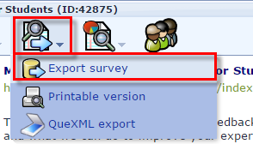

1. Choose **LimeSurvey XML survey file (*.lss)** and click **Export to file**.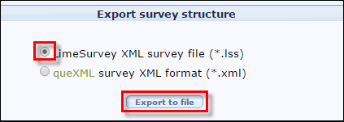

|  |
| --- |
| **IMPORTANT: I**f you have submission data from this survey that you have not exported, it will be inaccessible once the old version of LimeSurvey is decommissioned. We strongly advise you export the submission data into a file format, such as Excel for future reference. |

### Import an existing survey from .lss file

1. After you log into LimeSurvey, from the Surveys homepage, click **Create a new survey**.

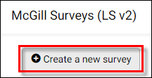

1. Click on the **Import** tab; then click **Choose File** and select the .lss file you exported from the previous survey.   
   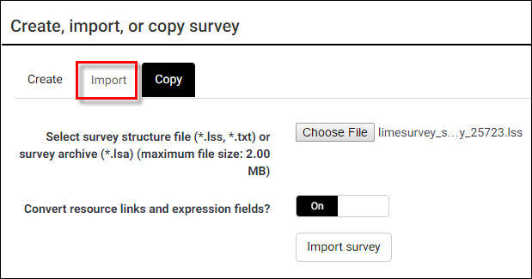
2. Click **Import survey**. If successful, you will see a “**Success**” page, with additional details about what was imported. You may also see additional **Warnings** if there were conditions the update feature was not able to handle. 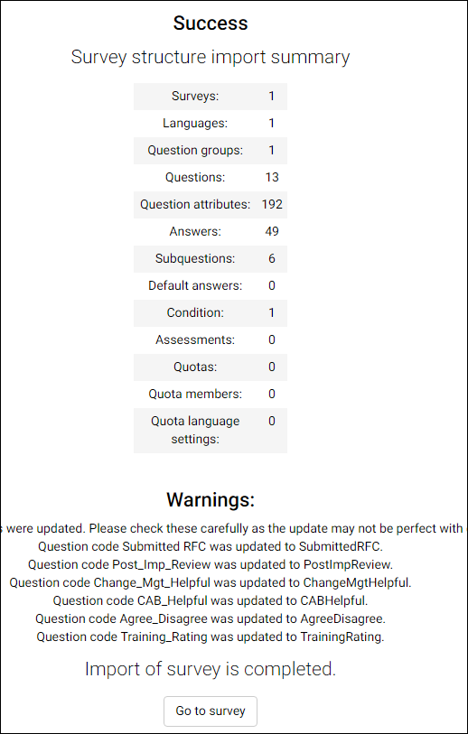
3. Click **Go to survey** to access the new survey.
4. Click **Preview survey**, in the top menu of the survey page and run through each question to ensure it behaves as expected.

After importing an older survey, you may want to choose a new template, or adjust the display and navigation settings. See instructions for **Survey Settings** below.

# Accessing your survey

After signing into the LimeSurvey site, click **List available surveys** to access the surveys for which you are the administrator.

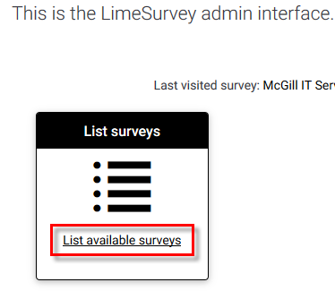

Then click the title of the survey you want to work on.

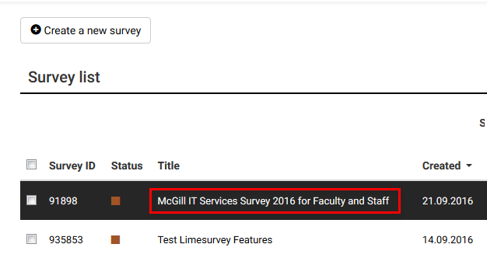

The Survey home page will open, where you have quick links to:

* Choose the **Format** (Question by question, Group by group or All in one)
* Add a new group
* Add new question
* Edit text elements and general settings
* Select your template
* Responses and statistics (available once responses are recorded)

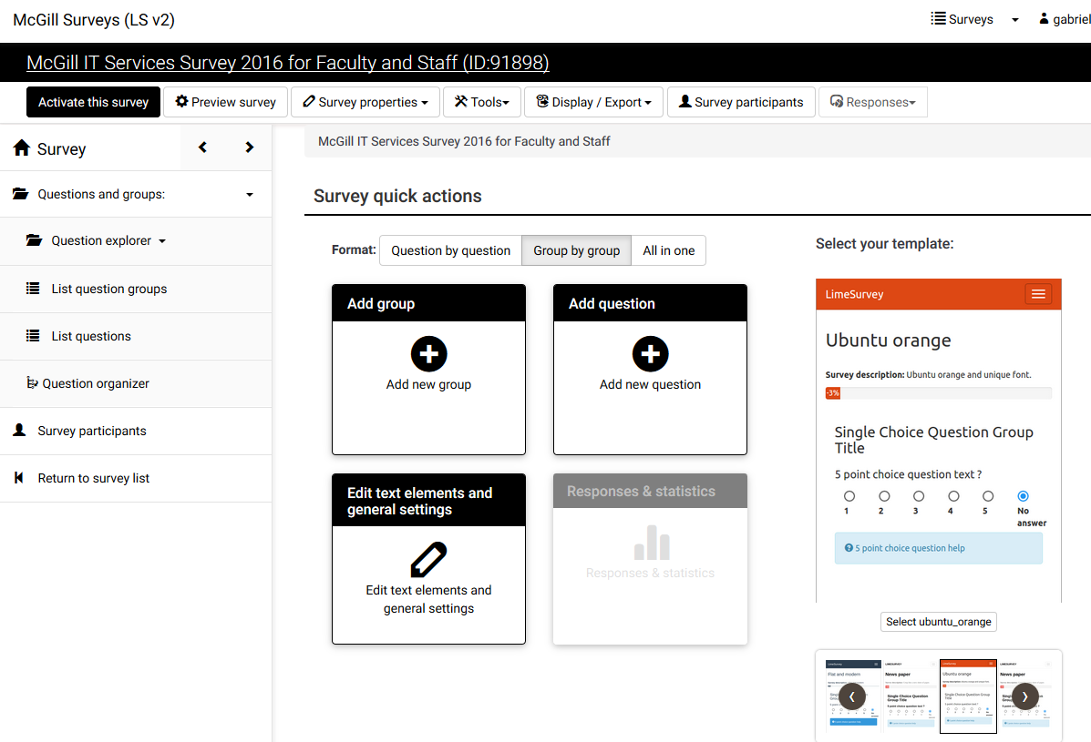

To get back to this page at any time, click on the Survey home link in the left side navigation pane:



# Survey Settings:

You can edit the appearance and general survey settings by clicking **Survey properties** > **General settings & texts** from the toolbar at the top of the Survey home page.  
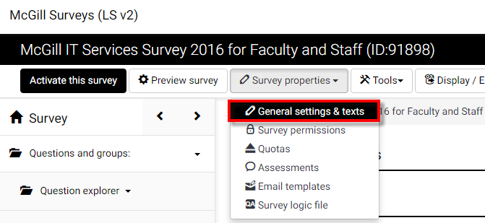

## Edit Text Elements:

From the **General settings & texts** page, you can enter / edit the following text elements:

* **Survey title** – appears at the top
* **Description** – for internal purposes
* **Welcome message** – the text participants see when they enter the survey,   
  “Your voice matters… ”
* **End message** – the message participants see when they submit their responses, e.g., “Thank you for helping improve… ”
* **End URL** - This URL will be presented as a link at the end of the survey, and allows you to direct your participants back to your home page (or, in fact, anywhere). The End URL has to start with "http://", eg. [http://www.mcgill.ca](http://www.mcgill.ca.)
* **URL description**: The description for the link using the End URL.

Notice that most of the fields contain WYSIWYG formatting controls to allow flexible text styling and images.

## General options:

On the right side of the Survey settings page, under **General options** you can select the language of the survey, name of the person who administers the survey, format of questions as well as the Template.

1. 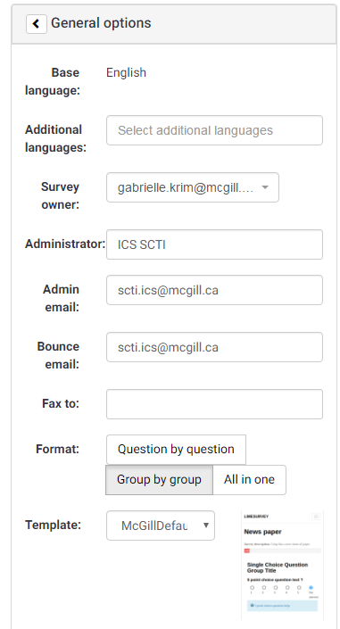**Base language**: This is set to English as the default.
2. **Additional languages:** If you wish to have the survey available in an additional language, select the language(s) here.
3. **Administrator**: This is the name of the contact person who administers the survey. It will be included in emails sent out inviting participants to respond.
4. **Admin email**: This is the email address of the administrator (as above) and is used as the 'reply to:' address on any emails sent. You can also enter several email addresses separated with a semicolon - that way survey administrator notifications are sent to more than one person.
5. **Bounce email**: This is the email address where a delivery error notification email should be sent. By default, this is the same as the administrator's email address.
6. **Fax to**: This field is used to give a fax number on the "printable survey" - ie: when you want to send someone a hard copy because they cannot use the online survey.
7. **Format**:
   * **Question by question: each question appears on a separate page**
   * **Group by group:** all questions in each group appear on the same page
   * **All in one:** all questions (and groups) for the survey appear on the same page
8. **Template:** Select the style you like best. You can make adjustments to the appearance and navigation in the Presentation & Navigation section.

## Presentation & navigation

Click on the section title “Presentation & navigation” to open that section and view the options:

1. 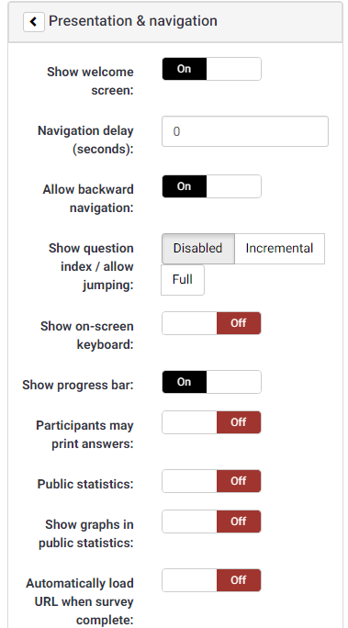**Show welcome screen**: On/Off.   
   If On, the welcome message defined in Text Elements section will be displayed. Default is On.
2. **Navigation delay**: Number of seconds before Previous and Next buttons are enabled. Default 0 seconds.
3. **Allow backward navigation**: This option defaults to On; however if you set it to "Off" users will not have the option of moving to a previous page while completing the survey.
4. **Show question index / allow jumping**: Disabled by default.  
   Incremental means participants can jump to any question within the same group. Full means participants can jump to any section in the survey.
5. **Show on-screen keyboard**: By activating this setting there will be a virtual keyboard available for certain question types.
6. **Show progress bar**: On/Off. Default is On. Displays a progress bar so participants can see how much of the survey is remaining as they answer each question.
7. **Participants may print answers**: Default is Off. When it is set to On, a participant can print a summary of their responses when they submit.
8. **Public statistics**:. Default is Off. If set to On, users who have submitted the survey will be presented a link to statistics of the current survey.
9. **Show graphs in public statistics**: Determines if public statistics for this survey include graphs or only show a tabular overview.
10. **Automatically load URL when survey complete**: Default is Off. If turned On, when the survey is submitted, it will automatically redirect the participant to the End URL specified in the **Text elements**.
11. **Show "There are X questions in this survey"**: On/Off. Default is On. If kept on, the message containing the number of questions will be displayed on the Welcome Screen.
12. **Show group name and/or group description**:   
    Controls the display of Group Names and Descriptions. Four Options:
    * **Show both** (Default)
    * **Show group name only**
    * **Show group description only**
    * **Hide both**
13. **Show question number and/or code**:
    * **Show both** (Default)
    * **Show question number only**
    * **Show question code only**
    * **Hide both**
14. **Show "No answer"**: Set to Off (Forced by system administrator).

### Publication & access control

1. **List survey publicly**: On/Off. Default is Off. When it is set to On, your survey will be listed in the 'available surveys' portal, accessible to anyone from the page: <https://surveys.mcgill.ca/ls>
2. **Start date/time**: Set this to a specific date if you want your survey to start on a certain date. The survey will start on midnight of that day and only then will people be able to answer to it. To disable this just clear the date from the input field.
3. **Expiry date/time**: Set this to a specific date if you want your survey to expire on a special date. This is the last date on which the public survey script will let people participate. To disable this just clear the date from the input field.
4. **Set cookie to prevent repeated participation?**: This setting allows you to retain control over multiple entries on public surveys. If you set this to On, a user working on the same computer will only be able to submit the survey once.
5. **Use CAPTCHA for survey access**: With this option you can decide if you want a CAPTCHA to be used to ensure a real person is accessing the survey and not an automated script. **Use**
6. **Use CAPTCHA for registration**: Set to On by default. It asks the user to enter a CAPTCHA text before entering the Registration page.
7. **Use CAPTCHA for save and load**: Set to On by default. It asks the user to enter a CAPTCHA text before Loading/Saving partial answers.

### Notification & data management

1. **Send basic admin notification email to:** and
2. **Send detailed admin notification email to:** Enter one or more email address if you want to send notifications whenever the survey is submitted.
3. **Date stamp**: When turned On, the date and time are recorded for all survey responses.
4. **Save IP address**: When turned On, the IP address of the respondent is saved.
5. **Save referrer URL**: When turned On, it saves the URL from which the respondent was led to your survey.
6. **Save timings**: When turned On, it records the length of time a user stays on one page while completing the survey.
7. **Enable assessment mode**: When turned On, the survey is treated as a quiz, which can be graded with correct/incorrect answers.
8. **Participant may save and resume later**: When turned On, it allows a participant to save his responses and resume to complete the survey at a later time.
9. **Google Analytics settings**: Google Analytics provides graphical data on the survey response rate and engagement, telling you when people came to the page, how long they stayed, where they came from and where they went afterward.
   * **None: No analytics performed**
   * **Use settings below: allows you to enter a Google Analytics API key**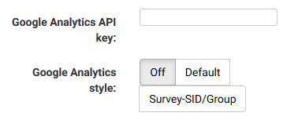
   * **Use global settings: Allows you to select the style for your Google Analytics report.**

## Tokens

1. **Anonymized responses:** When tokens are used to control survey access, this settings allows you to determine whether responses are matched up with information from your survey’s tokens table, or kept anonymous.
2. **Enable token-based response persistence**: When turned On, it allows the participant to resume after partially completing the survey.
3. **Allow multiple responses or update responses with one token:** If turned On, participants may return to his survey by clicking the invitation link, even if they have already submitted the survey. This only works when **Anonymized responses** is set to Off.
4. **Allow public registration:** When turned On, it allows anyone to complete the survey, while maintaining the use of tokens.
5. **Use HTML format for token emails:** When turned On, it allows your invitation email to contain HTML formatting.
6. **Send confirmation emails:** When turned On, a confirmation email is sent to the participant after submitting the survey.
7. **Set token length to:** Allows you to limit the number of characters for each token. The default length is 15.

# Question Groups

Survey questions are organized into **groups**. Each question must be a member of a **group** (and only that **group**). Depending on the number of questions in the survey, **groups** can be used to define logical sections, common subject themes, or pages on the screen. A group can have questions about a similar subject or simply be set up as a manageable number of questions.

A question **group** has a **Title** and an optional **Description**. You must have at least one **group** in each survey, even if you do not wish to divide the survey into multiple groups.

## [Creating a question group](http://docs.limesurvey.org/Creating+a+question+group&structure=English+Instructions+for+LimeSurvey)

1. Click on **Surveys** in the left navigation panel to access the Survey quick actions page.
2. Then click **Add new group**.  
   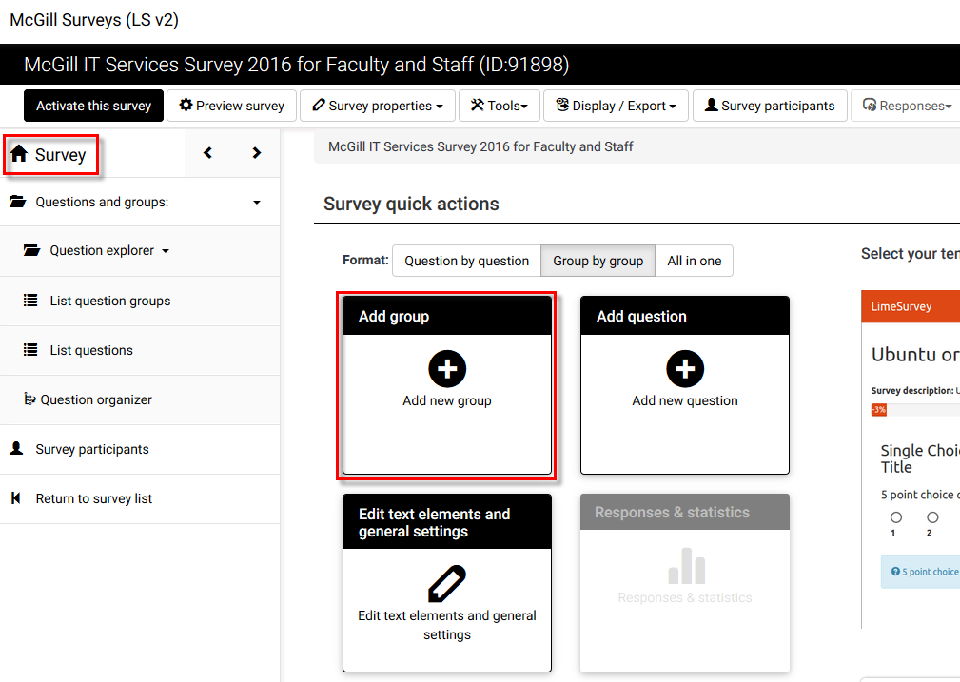
3. Enter a **Title** (required) and a **Description** (optional) for the group. Use the HTML editor for the description to include images, formatted text, etc.  
   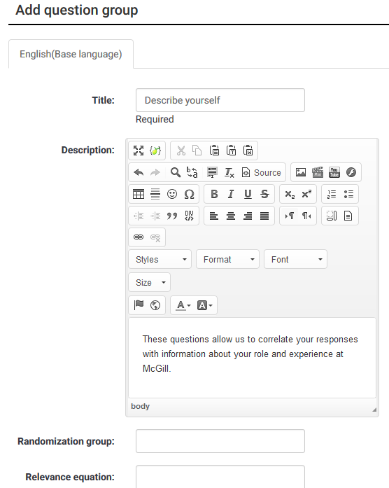  
   NOTE: The group title and description can be displayed or hidden, depending on your selection in the **Presentation and Navigation** section on the **Survey Settings** page.

## Editing or deleting a question group

Follow these steps if you want to change the title or description of a question group:

1. In the left side navigation panel, click **Questions and groups.**
2. Then click **List question groups.**
3. From **Question groups in this survey** page, click on the pencil icon next to the group you want to edit.

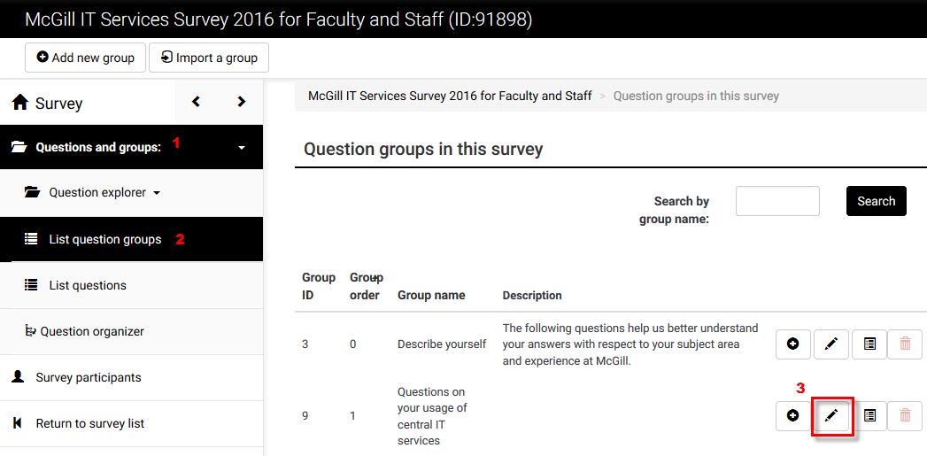

You can also delete a question group from this page by clicking the trash can icon: 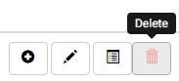

# [Adding question](http://docs.limesurvey.org/Adding+a+question&structure=English+Instructions+for+LimeSurvey)s

**Questions** are the core of your survey. There is no limit to the number of **questions** you can have in your **survey** or in a **group**. **Questions** include the actual question text as well as settings that determine the format of the response. You can also specify a short 'help' explanation for each question and determine whether the question is mandatory or optional.

### To add a question:

There are several paths you can take to add a new question.

|  |  |
| --- | --- |
| 1. From the **Survey** home page, click **Add new question**. |  |
| 1. From the **Question explorer** section of the navigation pane, click the plus sign [+] beside the name of one of the question groups to begin adding a new question to that group. |  |
| 1. If you’ve just added or edited a question, you can simply click the box labeled **Add new question to group** on the **Question summary** page. |  |

### Question fields:

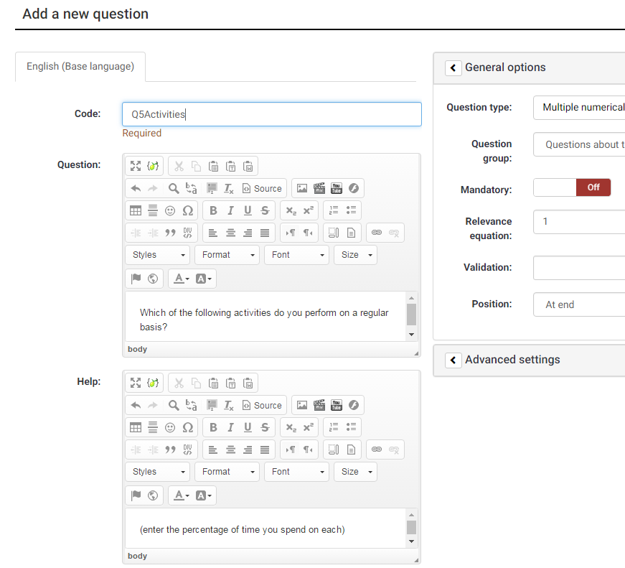

* **Code:** Enter a number or code for the question. This field is only for quick identification for a question in export or for evaluation. This field is normally not displayed to participants taking the survey.
* **Question:** This is the actual question being asked. There is no real limit to the length of the question. You can use the WYSIWYG editing controls to change the text styles or add images if needed.
* **Help:** This is an optional field. It is useful if a question needs some explanation, or you want to explain how it should be answered.

## General options

### **Question type:**

The type of question determines how the user interacts with and responds to the question. [There are many types](http://docs.limesurvey.org/Question+types&structure=English+Instructions+for+LimeSurvey) available**.** Roll your cursor over the name of each question type to view an example of how it will appear.

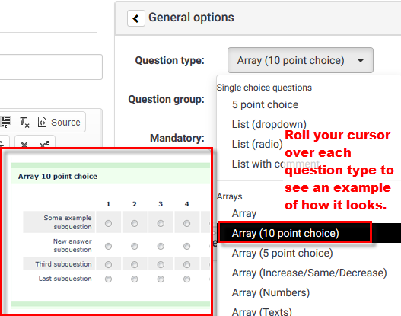

* [**Single choice questions**](http://docs.limesurvey.org/Question+types&structure=English+Instructions+for+LimeSurvey#Single_choice_questions)
  + [5 point choice](http://docs.limesurvey.org/Question+types&structure=English+Instructions+for+LimeSurvey#point_choice)   
    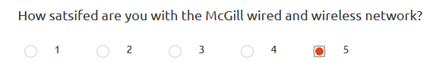
  + [List (Dropdown)](http://docs.limesurvey.org/Question+types&structure=English+Instructions+for+LimeSurvey#List_Dropdown_)   
    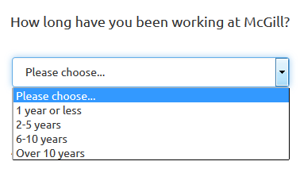
  + [List (Radio)](http://docs.limesurvey.org/Question+types&structure=English+Instructions+for+LimeSurvey#List_Radio_)   
    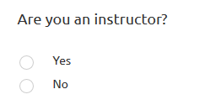
  + [List with comment](http://docs.limesurvey.org/Question+types&structure=English+Instructions+for+LimeSurvey#List_with_comment)
* [**Array**](http://docs.limesurvey.org/Question+type+-+Array&structure=English+Instructions+for+LimeSurvey): Arrays allow you to display a matrix, in which each row represents a different sub-question or item, and the answer options, labeled at the top, are available for each item.

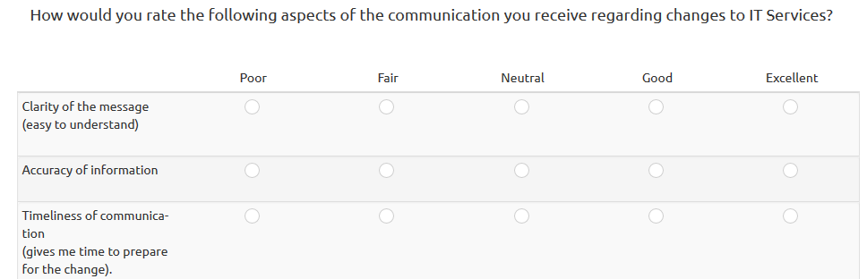

* [**Mask questions**](http://docs.limesurvey.org/Question+types&structure=English+Instructions+for+LimeSurvey#Mask_questions)
  + [Date](http://docs.limesurvey.org/Question+types&structure=English+Instructions+for+LimeSurvey#Date)
  + [File upload](http://docs.limesurvey.org/Question+types&structure=English+Instructions+for+LimeSurvey#File_upload)
  + [Gender](http://docs.limesurvey.org/Question+types&structure=English+Instructions+for+LimeSurvey#Gender)
  + [Language switch](http://docs.limesurvey.org/Question+types&structure=English+Instructions+for+LimeSurvey#Language_switch)
  + [Numerical input](http://docs.limesurvey.org/Question+types&structure=English+Instructions+for+LimeSurvey#Numerical_input)
  + [Multiple numerical input](http://docs.limesurvey.org/Question+types&structure=English+Instructions+for+LimeSurvey#Multiple_numerical_input)
  + [Ranking](http://docs.limesurvey.org/Question+types&structure=English+Instructions+for+LimeSurvey#Ranking)
  + [Text display](http://docs.limesurvey.org/Question+types&structure=English+Instructions+for+LimeSurvey#Text_display)
  + [Yes/No](http://docs.limesurvey.org/Question+types&structure=English+Instructions+for+LimeSurvey#Yes_No)

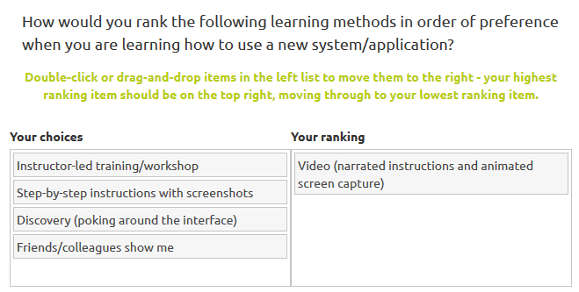

* [**Multiple choice questions**](http://docs.limesurvey.org/Question+types&structure=English+Instructions+for+LimeSurvey#Multiple_choice_questions)
  + [Multiple choice](http://docs.limesurvey.org/Question+types&structure=English+Instructions+for+LimeSurvey#Multiple_choice)
  + [Multiple choice with comments](http://docs.limesurvey.org/Question+types&structure=English+Instructions+for+LimeSurvey#Multiple_choice_with_comments)

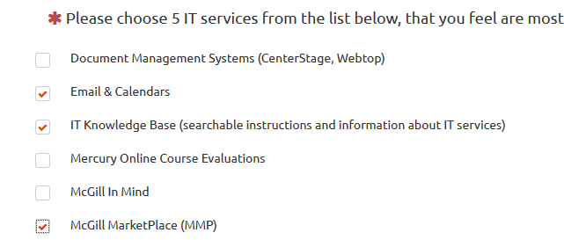

* [**Single choice questions**](http://docs.limesurvey.org/Question+types&structure=English+Instructions+for+LimeSurvey#Single_choice_questions)
  + [5 point choice](http://docs.limesurvey.org/Question+types&structure=English+Instructions+for+LimeSurvey#point_choice)
  + [List (Dropdown)](http://docs.limesurvey.org/Question+types&structure=English+Instructions+for+LimeSurvey#List_Dropdown_)   
    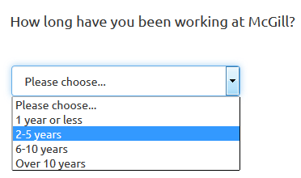
  + [List (Radio)](http://docs.limesurvey.org/Question+types&structure=English+Instructions+for+LimeSurvey#List_Radio_)
  + [List with comment](http://docs.limesurvey.org/Question+types&structure=English+Instructions+for+LimeSurvey#List_with_comment)
* [**Text questions**](http://docs.limesurvey.org/Question+types&structure=English+Instructions+for+LimeSurvey#Text_questions)
  + [Huge](http://docs.limesurvey.org/Question+types&structure=English+Instructions+for+LimeSurvey#Short_free_text) free text
  + [Long free text](http://docs.limesurvey.org/Question+types&structure=English+Instructions+for+LimeSurvey#Long_free_text)
  + [Multiple short text](http://docs.limesurvey.org/Question+types&structure=English+Instructions+for+LimeSurvey#Multiple_short_text)
  + Short free text  
    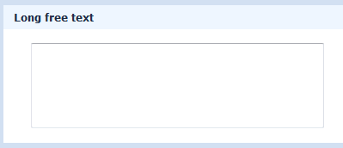
* **Question group: You can select any group for the question. However, beware of switching questions between groups if you have conditional logic in your survey.**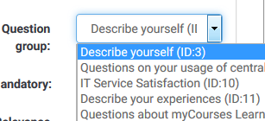
* **Option ‘Other’:** If you select a question type that contains options(i.e., single-select list or multiple select list), you can allow participants to select ‘Other’ and enter their own text.   
  
* **Mandatory:** Turning On this setting allows you to require users to answer the question, before they can move on to the next page of the survey. For ranking question Mandatory means all items have to be ranked.   
  

## Advanced settings

The advanced settings available depend on the question type selected.

### Display

These settings allow you to specify visual/interaction options. Here are a few examples:

**Use slider layout** - allows you to choose sliders or stars for questions of type 5-point choice.  
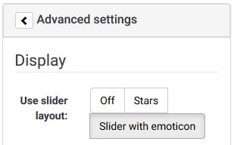

**Category separator** is a display option used with List type questions. It allows you to enter a separator character if your options are grouped

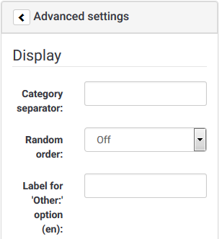

### Input

For question types that require the user to enter text or numeric data, this section contains options for restricting the length, min/max value or type of data they enter.

### Logic

This section contains options for dealing with the response. For example, if you are creating a survey with assessment questions, you can specify which values correspond to ‘Correct’ answers, and provide feedback to users depending on what they enter.

### Statistics

This section allows you to display the current results to participants if you wish. If you turn **Show in public statistics** On, and **Display chart** is On, you can choose what **Chart type** to display (Bar, Pie, Line, etc.)

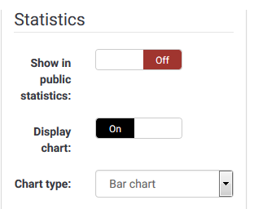

## [**Adding answers or sub-questions**](http://docs.limesurvey.org/Adding+answers+or+subquestions&structure=English+Instructions+for+LimeSurvey)

Various question types require you to add a list of answer options and/or sub-questions. To add answers to one of these question types click on the "**Edit answer options**” button at the top of the **Question summary** page.  
 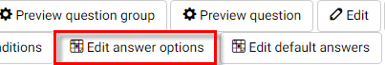.  
  
When adding an answer you will be asked for an "Answer Code" and an "Answer”.

1. **Answer code:** This is the data that will usually be exported to your spreadsheet when compiling results. You may choose whatever code you want (5 character maximum). The code can only contain standard alpha-numeric characters.
2. **Answer:** The answer that will be displayed.
3. **Position:** Click and drag the cross-hair icon beside each answer option to change its position in the list.

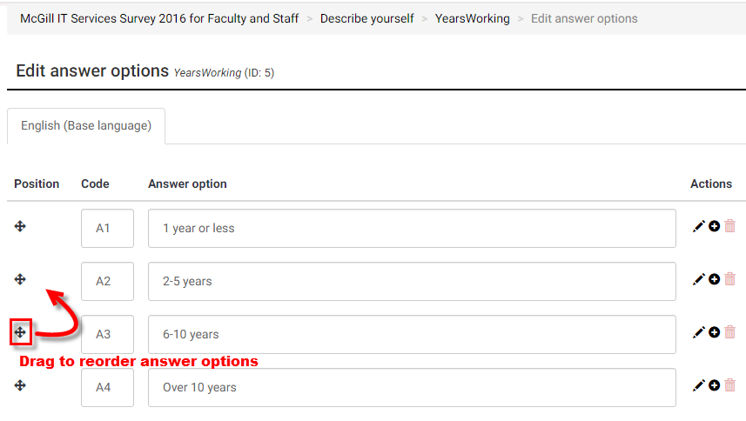

1. **Default:** To set a default answer for the question, click on the "**Edit default answers**” button at the top of the **Question summary** page.

If you don't choose any default answer the survey result will record nothing if one of the answer options is not specifically chosen.  
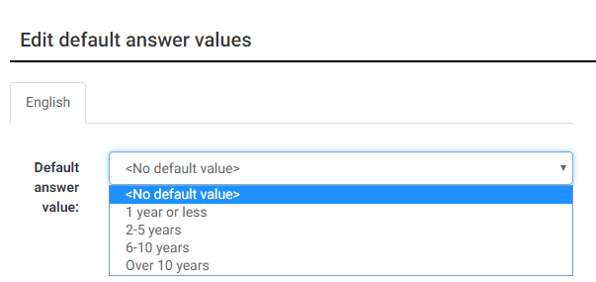

## Reorder groups or questions within a group

1. From the left side navigation panel, click **Questions and groups**;
2. Click **Question organizer**.
3. On the **Organize question groups/questions** page you can reorder groups or individual questions by clicking and dragging their titles to the desired position.
4. Click **Save** at the top of the page when you are done.

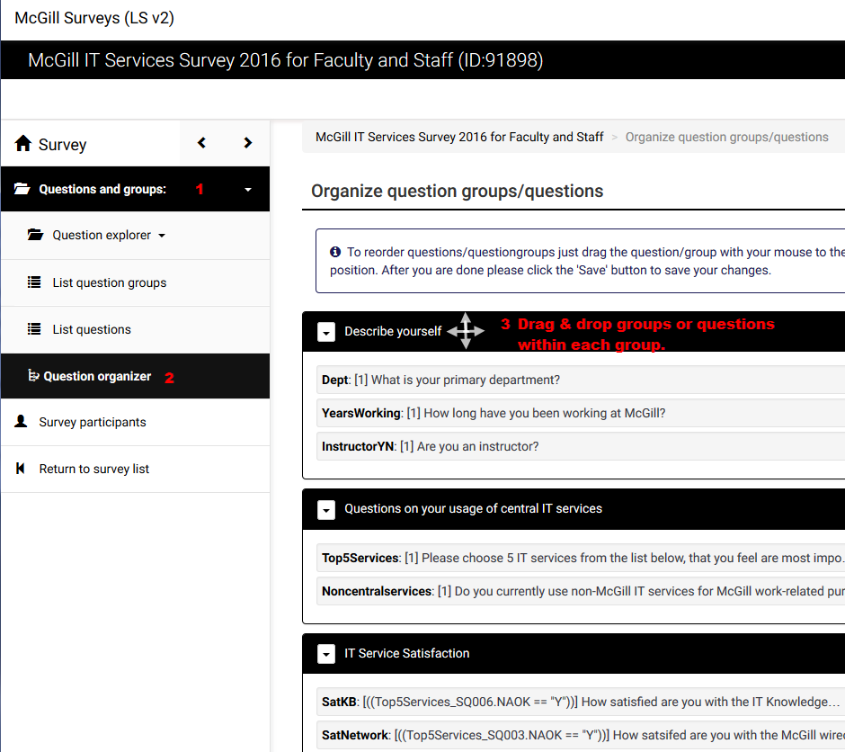

## [Setting conditions](http://docs.limesurvey.org/Setting+conditions&structure=English+Instructions+for+LimeSurvey)

By default, all questions in a survey are displayed. However, you may want to show or hide questions depending on how a participant responds to previous questions.

You do this by setting up a condition or set of conditions on the question(s) that you want to show or hide.

### Setting a simple condition for a question

1. From the navigation panel by clicking **Questions and groups > Question explorer**.
2. Click on the question that you want to show or hide (depending on responses to previous questions in the survey).
3. Click **Set conditions** from the menu at the top of the question page to open the **Conditions designer** page.

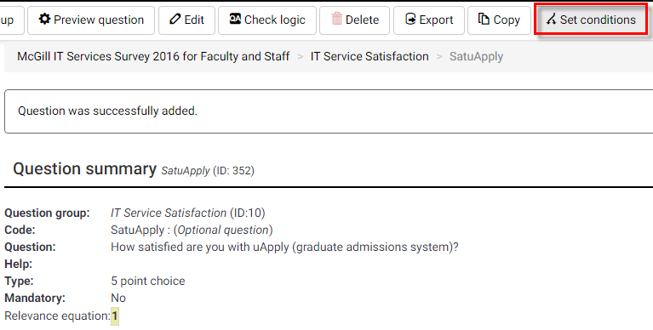

1. In the **Add condition** section the most common type of condition is based on **Previous questions** – where the conditional display of the current question is based on the participant’s answer to a prior question in the survey.
2. Select the **Previous questions** tab; then select the question or sub-question that the condition is based on.  
   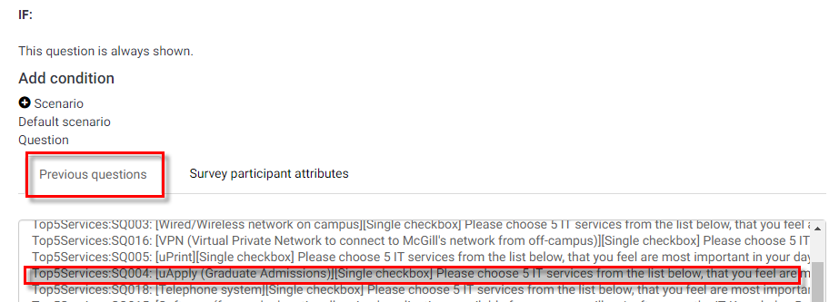
3. Choose the **Comparison operator** (equals, not equal to, etc.).  
   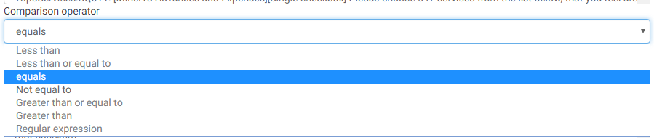
4. Then choose the **Answer** option that corresponds to the condition on which the question will be displayed.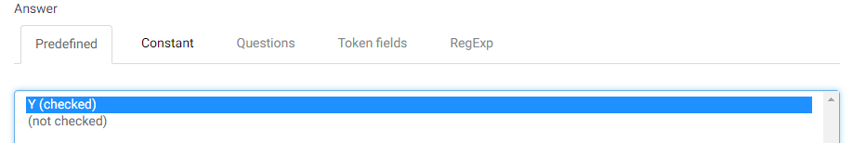
5. Click **Add condition**, at the bottom to save it.   
   The condition will appear at the top of the page.

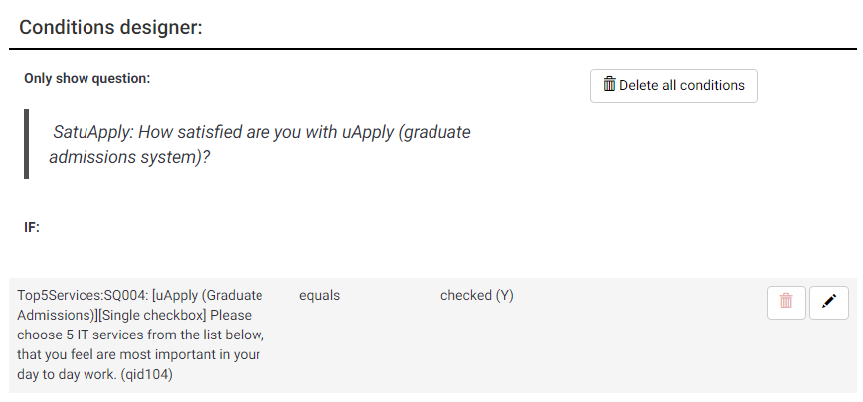

1. Click the **Close** button at the top to return to the **Question summary** page.

**NOTES:** You may also specify conditions based on attributes of the person filling out the survey. To do so, select **Survey participant attributes**. Then select the attribute for the condition, the comparison operator and the value to compare.

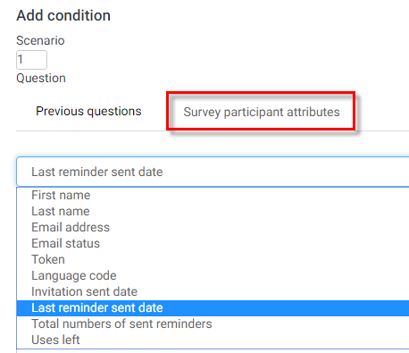

You can add multiple conditions for the same question if needed.

|  |
| --- |
| **TIP:** When using conditions, it is recommended to test/preview your survey flow with all response combinations to make sure your conditions are working as expected. |

### Setting conditions on a question group

Your survey may need to show or hide a whole group of questions, based on participants’ responses to previous questions. For example, some surveys require participants to click “Yes” on a privacy agreement before having access to the remaining survey questions.

There is no direct way to set up a condition on a question group. However, you can achieve the same result by following these steps:

1. Select the first question in the group that you want to be able to show or hide, and set up the condition on that question (by following the steps for a simple condition, above).
2. When you close the set conditions window, you will see that the **Relevance equation** for that question now has a conditional statement on it, as shown below.
3. Copy that **Relevance equation** from the **Question**.

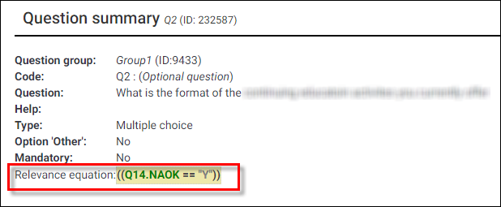

1. From the **Question explorer**, click the **Group summary** icon, next to the question group that you want to show/hide.  
     
   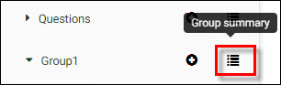
2. Click **Edit current question group**, at the top of the page and paste the condition you copied into the Relevance equation box for that group.  
     
   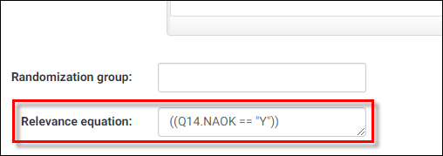

Now the condition will apply to the entire group of questions.

1. Test your survey to make sure it behaves as desired.

# [Managing Surveys](http://docs.limesurvey.org/Managing+Surveys&structure=English+Instructions+for+LimeSurvey)

## Preview the survey, a question group or an individual [question](http://docs.limesurvey.org/Question+preview&structure=English+Instructions+for+LimeSurvey)

### Preview survey

To preview the entire survey, click the **Preview survey** button at the top of almost any page.  
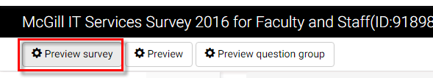

### Preview question group

To preview a question, click **Preview question group** at the top of the **Group summary** page. To get to the Group summary page, from the left side navigation pane, click **Questions and groups > Question explorer**; then click on the **Group summary** icon beside the group name.

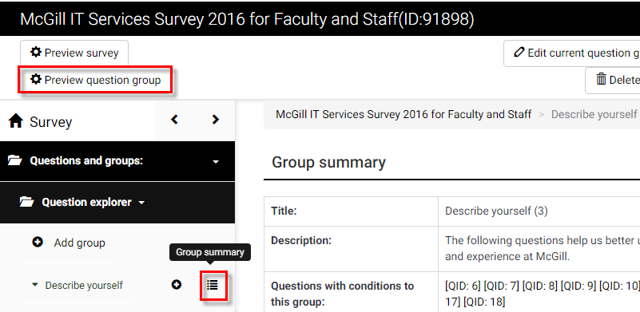

### Preview question

To preview a question, click **Preview Question** at the top of the **Question summary** page. To get to the Question summary page, from the left side navigation pane, click **Question Groups > Question explorer** > click the arrow to the left of the group name to open it; then click on the question.

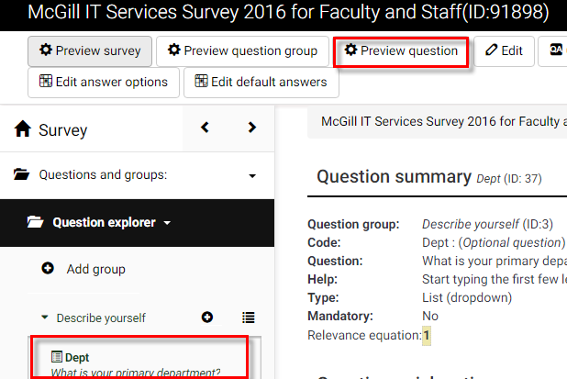

## [Activate a survey](http://docs.limesurvey.org/Activating+a+survey&structure=English+Instructions+for+LimeSurvey)

Once you are happy with the structure of your survey you can activate it by clicking **Activate this survey**, from the Survey homepage.  
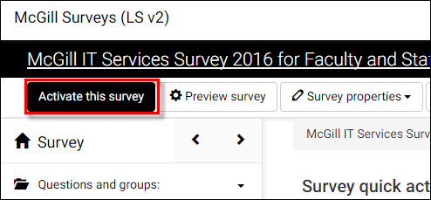

|  |
| --- |
| **Before you activate a survey, note the following:**   * Once the survey is activated, you can change the text of questions and answers, or general text that appears on the survey, but you cannot change a question or answer type. * You cannot add or delete questions. * You cannot add answers to any of the array or multiple choice questions - however you can add answers to the basic list type questions. |

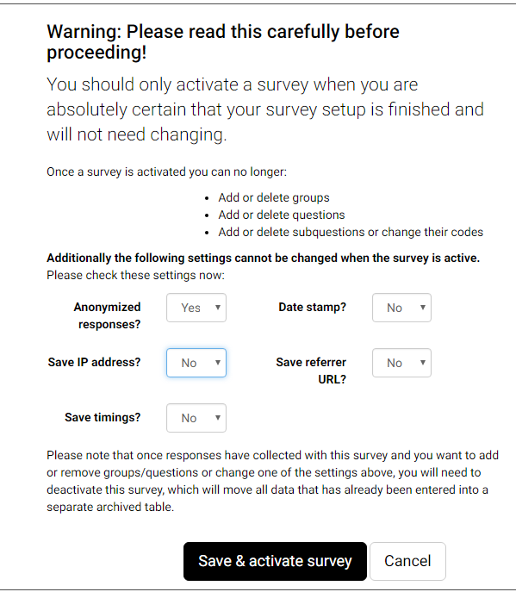

You will be prompted to verify the survey settings which cannot be changed.

Click **Save & activate survey** when you are ready to make it live.

## [Browse survey results](http://docs.limesurvey.org/Browsing+survey+results&structure=English+Instructions+for+LimeSurvey)

When your survey is active, the top menu bar options change.



You will now see a menu named **Responses**, which contains options to view the Responses that have been submitted.

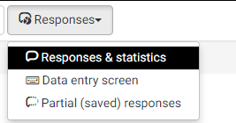

1. Click **Responses & Statistics**. The Response summary screen opens and displays the following information:

* The total number of full responses received (submitted)
* The total number of incomplete responses recorded
* The total number of responses recorded (full response and incomplete responses)

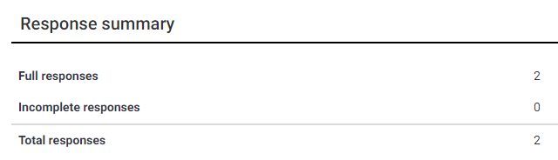

## View survey results

In order to view individual participant responses click the “**Display responses**” from the menu.

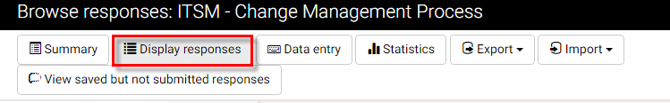

You will see a table with all participant responses for all questions.

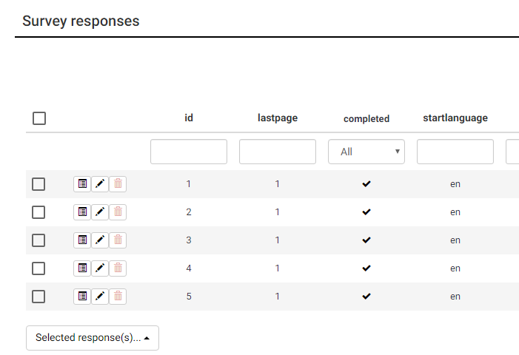

You can use the dropdown list under the **completed** column to view **All** responses or only those completed (**Yes**), or not completed (**No**).

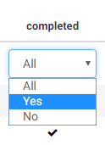

To view an individual participant’s responses, click the “**View response details**” icon on the row corresponding to the participant.



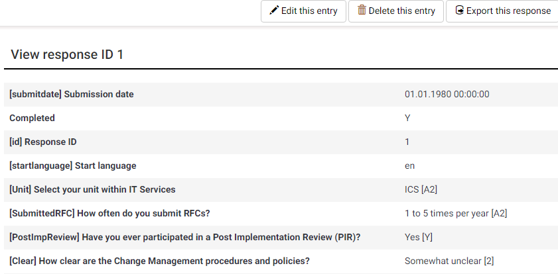

View Statistics

From the **Responses and Statistics** page, click **Statistics.**

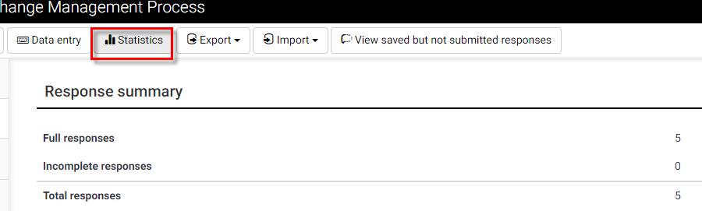

By default, you enter **Expert mode**, where you have options to filter the data and display it as you wish.

### General filters

Under **General filters,** there are many options for displaying the responses.

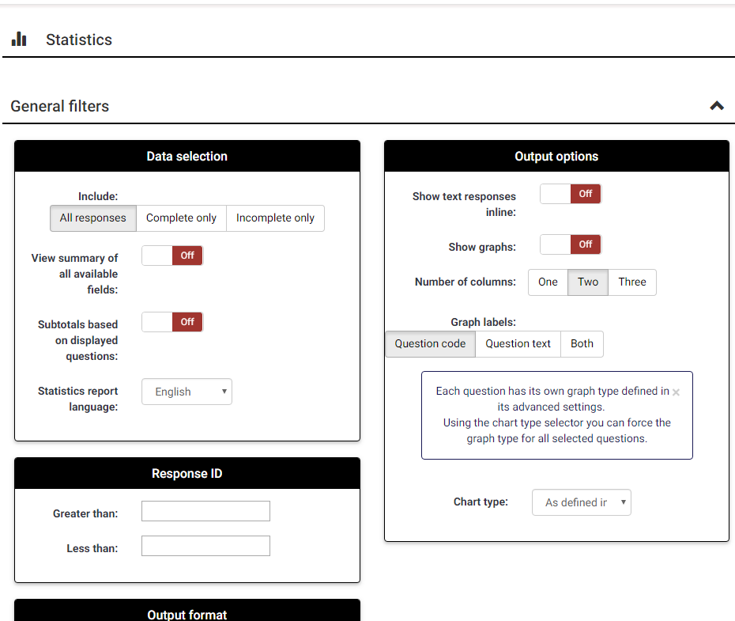

**Data selection:** Allows you to filter the data to display based on the completeness of responses, elect to view a summary of fields subtotals.

**Response ID:** Allows you to specify a range of IDs to include – only applies if your participants are given unique IDs.

**Output format:** HTML, PDF, Excel

**Output options:** Show text responses inline (as opposed to a separate table), Show graphs [On/Off], Graph labels (Question code, Question text or Both) Chart type (select from a variety of styles).

### Response filters

In this section, you can filter which responses to include in your analysis. Hold down the **Ctrl** key to select/de-select multiple options in each response list.

## View and interact with statistics

Once you have specified the data you want to view, click **View statistics** to view the resulting analysis.

If you turned **Show graphs** ON under **Output options**, you will see one chart for each question, corresponding to your selections on the **Response Filters** section.

### Interact with charts dynamically

Click the buttons at the bottom of a chart to change the type. 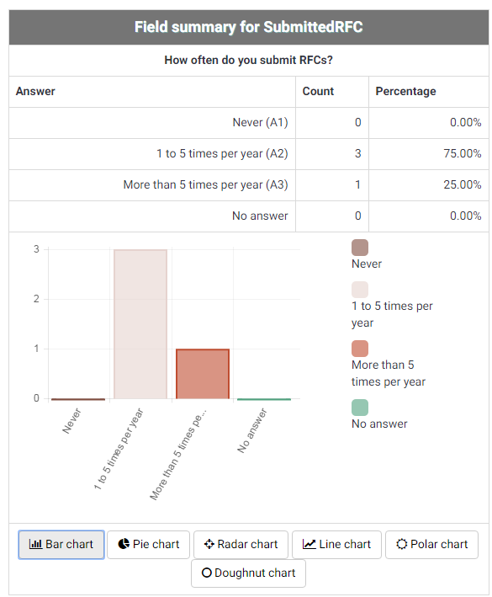

Click on a data point/bar/pie wedge to view details about it.

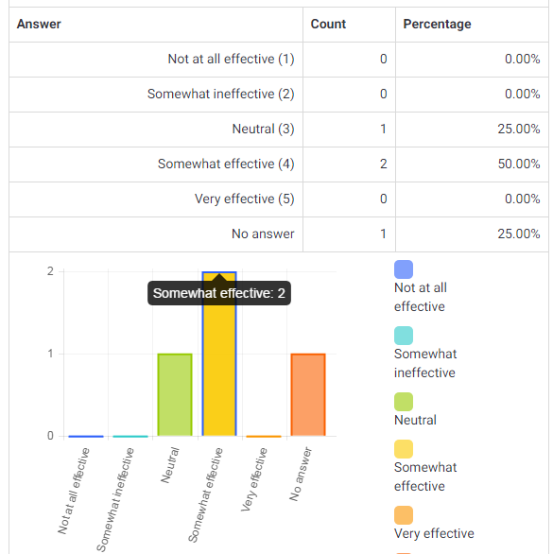

### Simple mode

Click **Simple mode** on the **Statistics** page to get a quick overview of responses.



A simple bar graph is displayed for each question.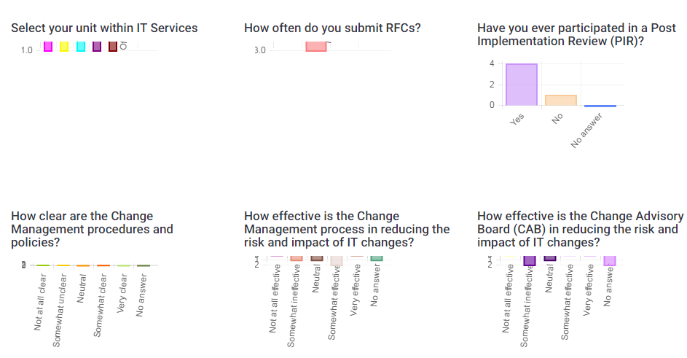

[Close a survey](http://docs.limesurvey.org/Closing+a+survey&structure=English+Instructions+for+LimeSurvey)

There are two ways for closing a survey: Expiration or Deactivation.

### Expiration

Within the **Survey Settings** > **Publication & access control** section, you can set an "**Expiry date/time"**. The survey will automatically close on that date.

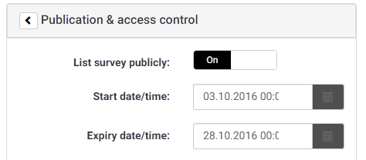

### Deactivation (stopping the survey manually)

From the survey homepage, click **Stop this survey** in the menu at the top.

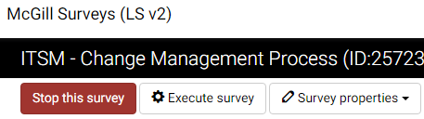

After clicking **Stop this survey**, you will be prompted to choose between **Expire survey** and **Deactivate survey** options.

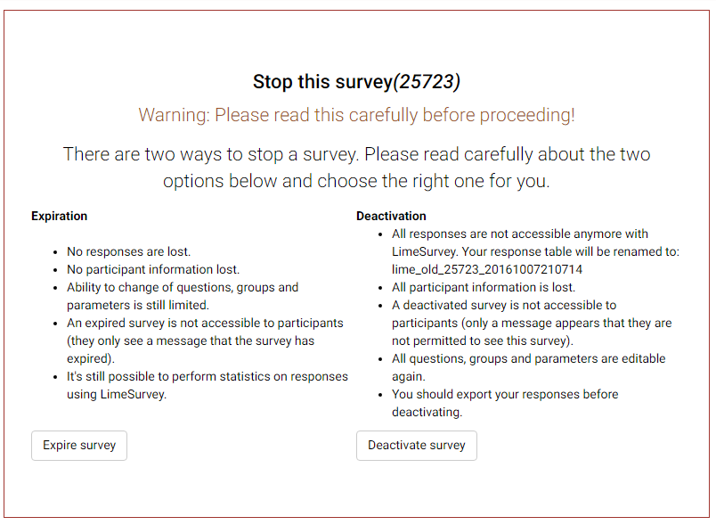

|  |
| --- |
| **IMPORTANT: Once the survey is Deactivated, all results are no longer accessible through LimeSurvey, and all participant information is lost. Therefore, it is critical to export and save your data before deactivating the survey.** |

## 

## [Exporting results](http://docs.limesurvey.org/Exporting+results&structure=English+Instructions+for+LimeSurvey)

At any point while your survey is active, or if it is expired, you can view and export the responses.

* + - 1. Click **on Responses and choose** **Responses & Statistics** from the Survey menu bar. 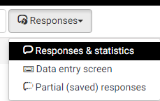
      2. Click the **Export** menu and select one of the export methods:

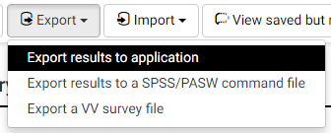

### Export results to Excel

1. From the top of the **Responses & Statistics** page, click **Export** > “**Export Results to application**”.

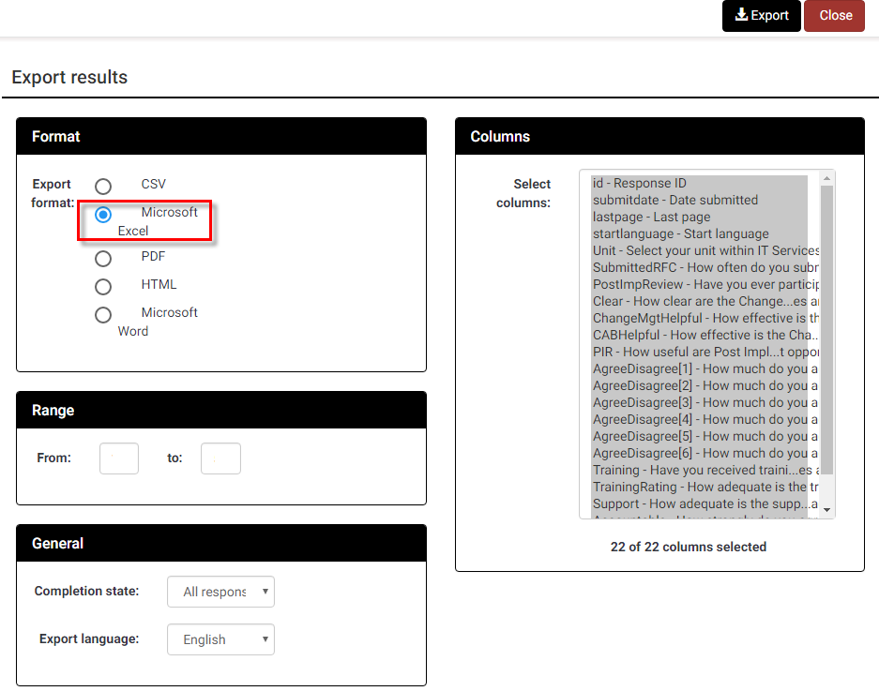

Fill it out the options on this screen according to the information you would like to capture in the Excel table:

* **Export format:** Choose **Microsoft Excel** if you want to view and manipulate the date with Excel. You can also choose PDF, HTML, CSV or Microsoft Word.
* **Range:** Select the range of questions you want to appear (the default is all questions)
* **Completion State:** Select from “All responses”, “Completed responses only” or “Incomplete responses only”
* **Export language:** Applies to surveys that are made available in multiple languages.
* **Headings:** Select how you would like the column headings to display. Choices include: “Question code”, “Abbreviated question text”, “Full question text”” or “Question code and question text”.
* **Responses:** Select how you would like the answers to display. Choices include: “Answer codes” or “Full answers”. If you want answer codes to be displayed you can set whether you want Y and N answers to appear as 1 and 2.
* **Columns:** Choose the columns you would like to appear in the file. All data is selected as the default. Use the CTRL key to select specific columns.

Click **Export** at the top of the window. Data will be exported to the chosen file format, and will be downloaded by your web browser, to your default downloads folder.

Depending on your web browser settings you may be prompted to save it in a location of your choice or open it directly in the application you selected.

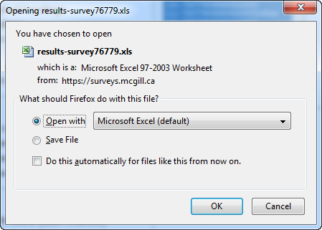

### Exporting survey data in SPSS

From the Reponses and Statistics page, click Export > Export results to a SPSS/PASW command file.

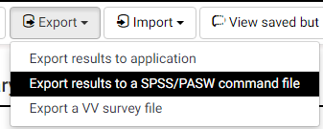

The following screen will appear:

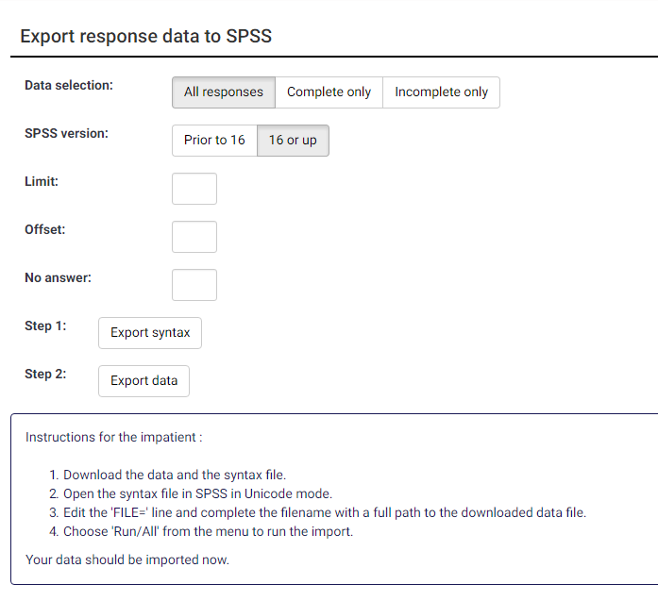 Top of Form

Fill out the following fields:

* **Data selection:** Select from “All responses”, “Completed responses only” or “Incomplete responses only”
* **SPSS version:** Choose whether you are using version” 16 or up” or “Prior to 16”
* Click “**Export Syntax**” and “**Export Data**” to download the data and the syntax file.

Follow the instructions displayed on screen:

1. Download the data and the syntax file,
2. Open the syntax file in SPSS in Unicode mode.
3. Edit the “FILE=” line and complete the filename with a full path to the downloaded data file.
4. Choose 'Run/All' from the menu to run the import.

Your data will now be imported.